

|  |  |  |
| --- | --- | --- |
| **Module Code** | **:** | AAPP009-4-2-WDT – WEB DEVELOPMENT |
| **Intake Code** | **:** | UCDF2208ICT(SE) |
| **Lecturer Name** | **:** | MR MOHAMAD FIRDAUS CHE ABDUL RANI |
| **Tutorial No.** | **:** | T20 |
| **Group Leader** | **:** | MR CHEAM SHENG TING (TP071172) |
| **Project Title** | **:** | DogeHub |

|  |  |
| --- | --- |
| **Student ID** | **Student Name** |
| TP071064 | MR CHIEU ETEN |
| TP071258 | MR LEE KAI YANG |
| TP071367 | MR EDWIN CHEN CHOON MUN |
| TP071180 | MR CHAI MING XUAN |

**1.0 INTRODUCTION** 4

**2.0 DESIGN** 5

2.1 Entity Relationship Diagram 5

2.2 Website Navigational Structure 5

2.3 Data Dictionary 6

2.4 Wireframe 7

2.4.1 Guest Interface 7

2.4.2 User Interface 9

2.4.3 Admin Interface 11

**3.0 IMPLEMENTATION** 13

3.1 Login and Sign in Page 13

3.2 Admin View Donation Page 17

3.3 User Donate Page 20

3.4 Adopt Page 30

3.5 Admin Add Dogs Page 38

3.6 Admin Applicants Page 41

**4.0 USER GUIDANCE** 44

4.1 General 44

4.1.1 Login 44

4.2 User 45

4.2.1 Sign Up/Register 45

4.2.2 Home Page 46

4.2.3 About Us 46

4.2.4 Adopt Page 47

4.2.5 Application 50

4.2.6 Donate Page 52

4.2.7 Log Out 60

4.3 Admin 61

4.3.1 Home Page 61

4.3.2 Edit Adoption 61

4.3.3 View User’s Application 63

4.3.4 View Total Donation 65

4.3.5 Log Out 66

**CONCLUSION** 67

**REFERENCES** 68

**WORKLOAD MATRIX** 69

# 

# **1.0 INTRODUCTION**

DogeHub, a platform designed for our four-legged friends! Our mission is to create a better environment for the strays and find them a warm and happy home. DogeHub will be your go-to if you are interested in adopting a dog or helping them just by making some donations. The website includes various features for ease of management and lets users have a better connection with all the details info of the doggies.

For registered users, they will be able to browse dog profiles and view details of the dog, it helps users on seeking their dream dog. Users can also make donations with the functions provided to support us! It’s all about making all the complex procedures easy and clear.

As stated, all the functions were built specifically to make all the process easier. For example, Admin can edit and update dogs’ info easily on the website with real-time update, user will be able to view latest info of dogs to avoid any kind of confusion, they can also search for a dog just by its name or with relevant details. Not only that, but Admin can also manage all the donation within the website, whenever a user donates, the info will immediately be updated into the donation details page that can only view by the admin, admin can see all the details of that donation which includes Donator name, contacts etc. With these functions, record can be done easily with more efficiencies.

# **2.0 DESIGN**

## 2.1 Entity Relationship Diagram

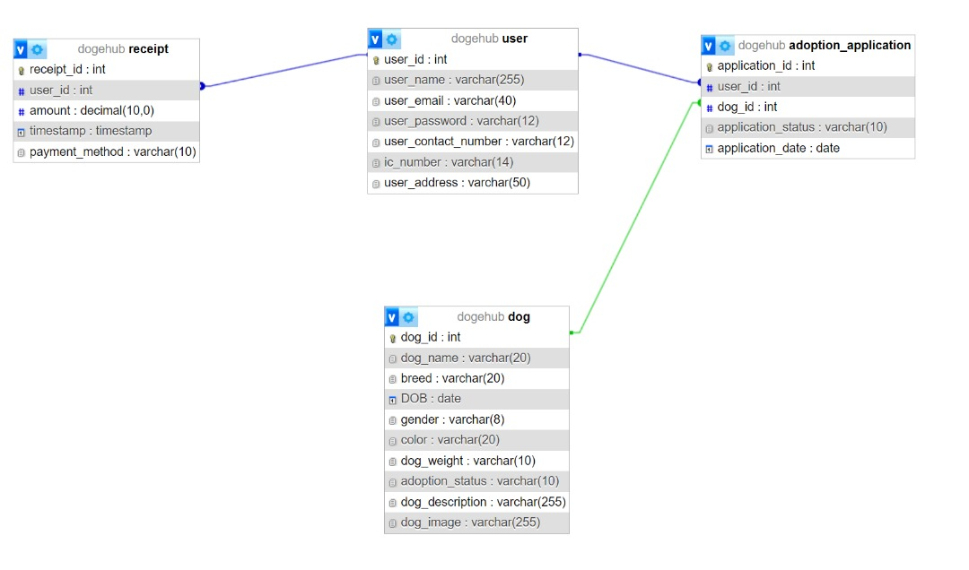

## A diagram of a company Description automatically generated2.2 Website Navigational Structure

Navigation structure of Dogehub website

## 2.3 Data Dictionary

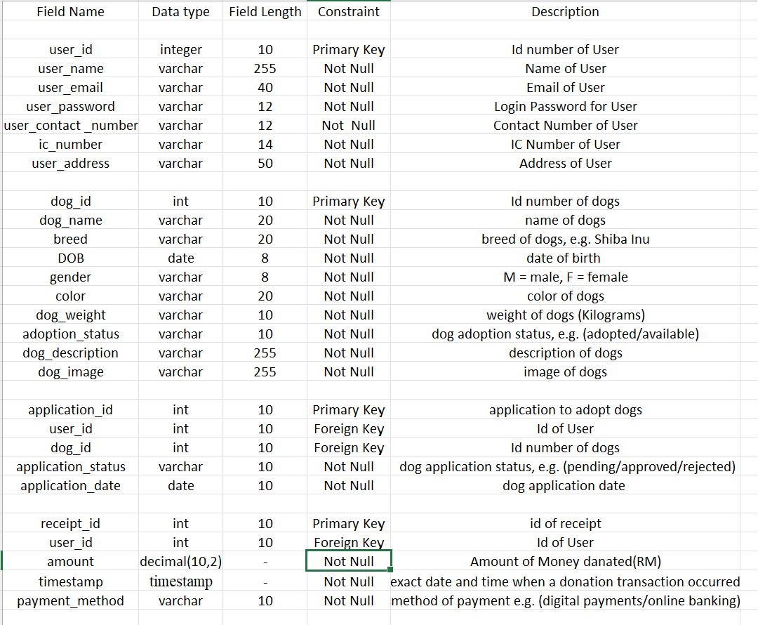

## 2.4 Wireframe

### 2.4.1 Guest Interface

**Home page**

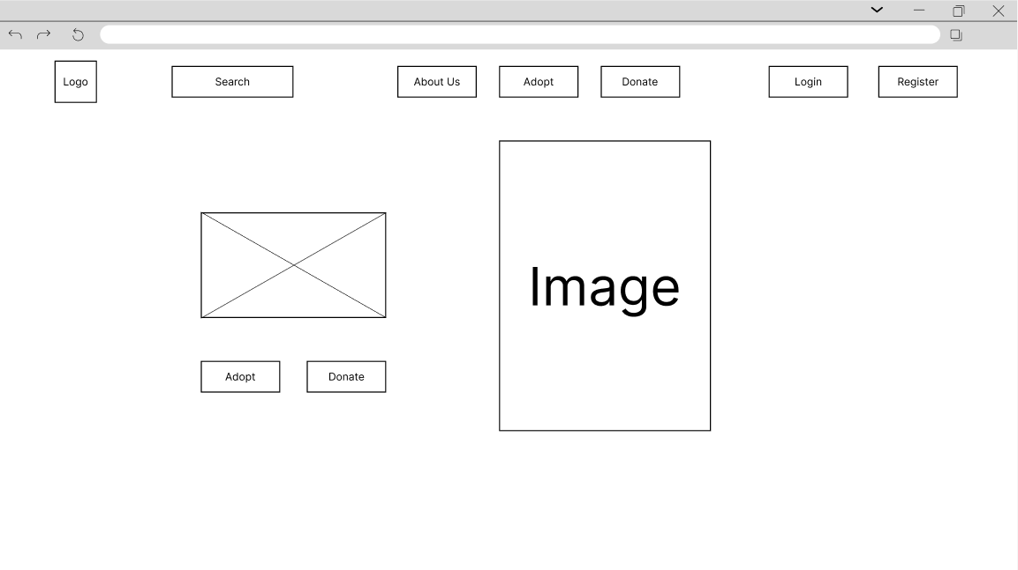

In Guest Home page will include buttons that redirect to other function pages, such as About Us, adopt, Donate, Login and Register.

**About Us**

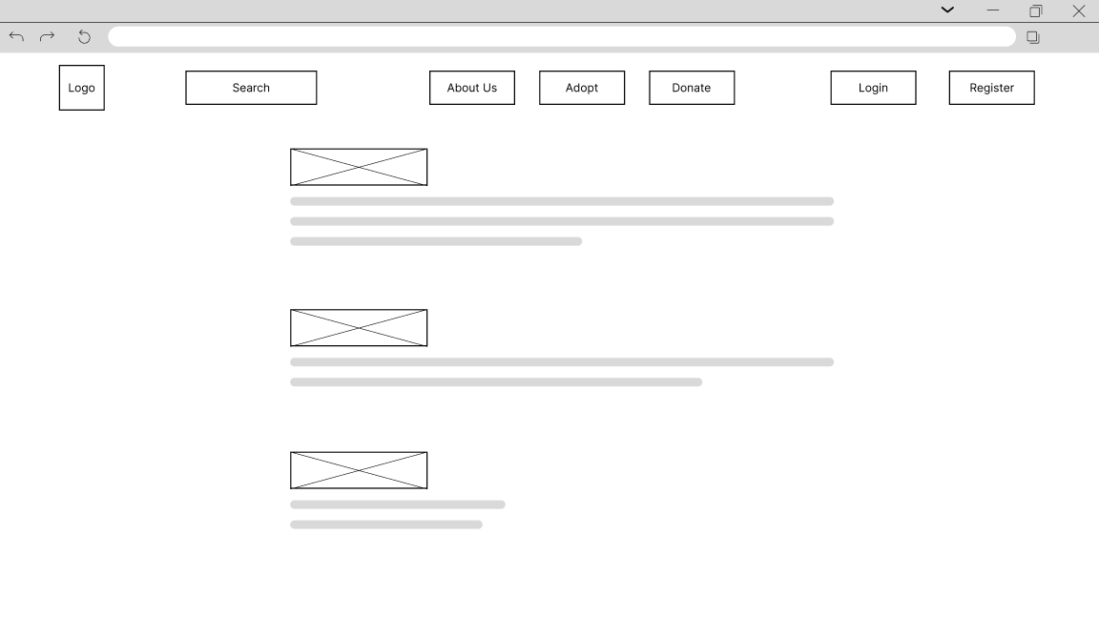

About Us would consist of information of the platform and contact information.

**Adopt**

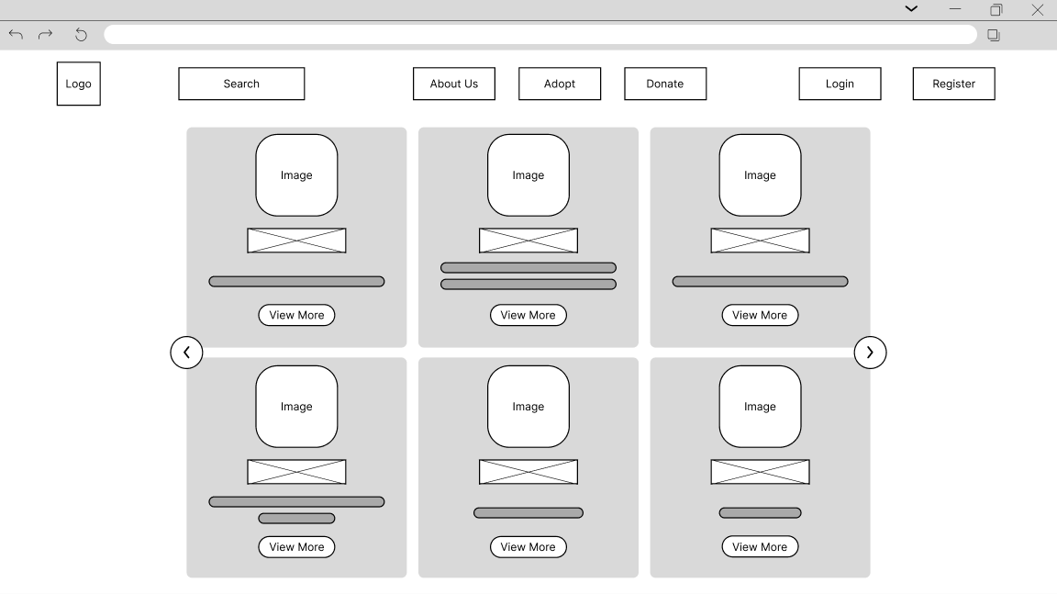

Adopt page shows basic information of dogs with their picture, Guest can click “View more” to see further information.

**Donate**

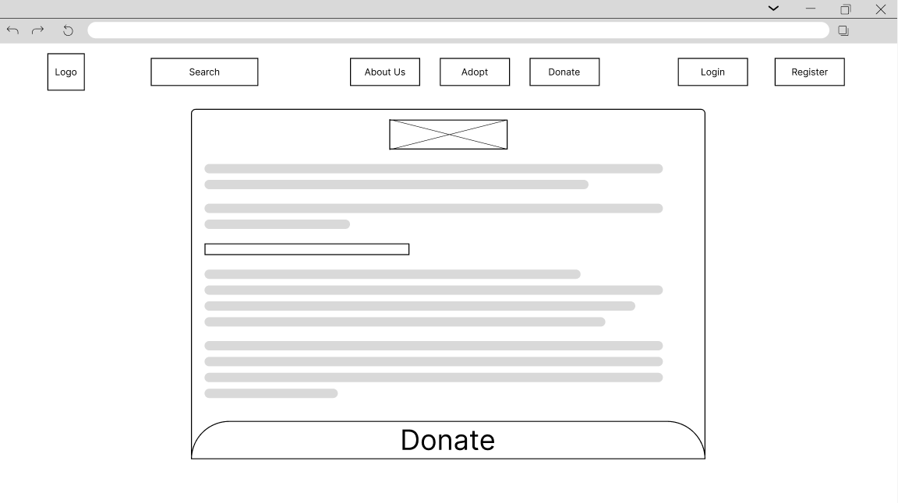

In the donate page, there will be brief explanation of reason of donations and how would it help.

### 2.4.2 User Interface

**Home Page**

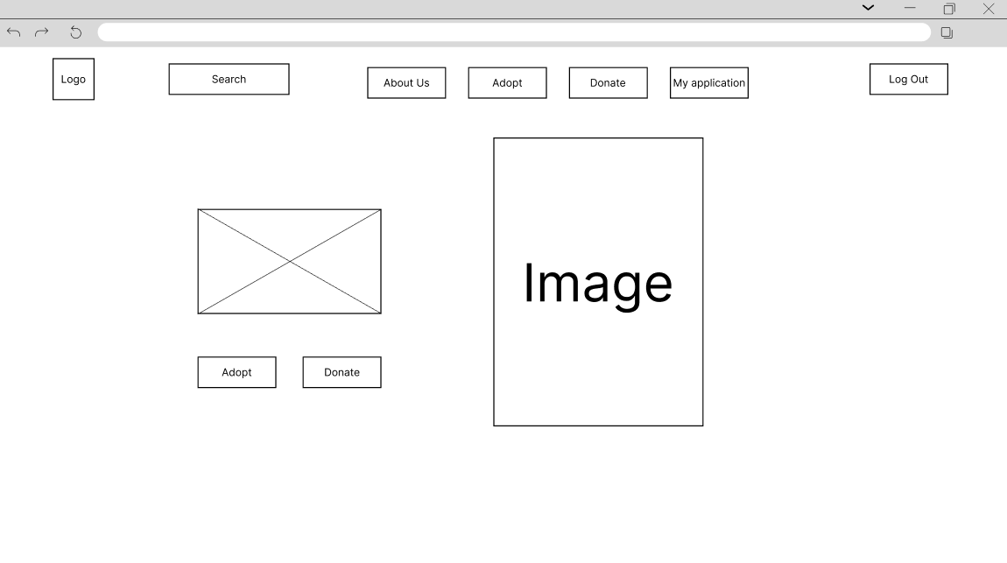

User Home page will include buttons that redirect to other function pages, such as About Us, adopt, Donate, My application and Log Out.

**About Us**

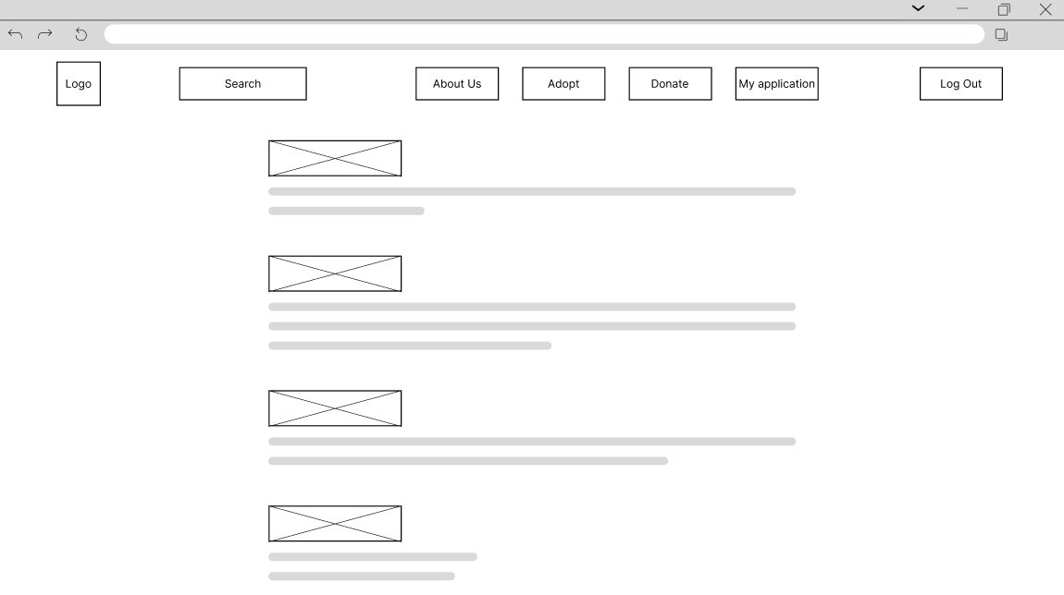

About Us would consist of information of the platform and contact information.

**Adopt**

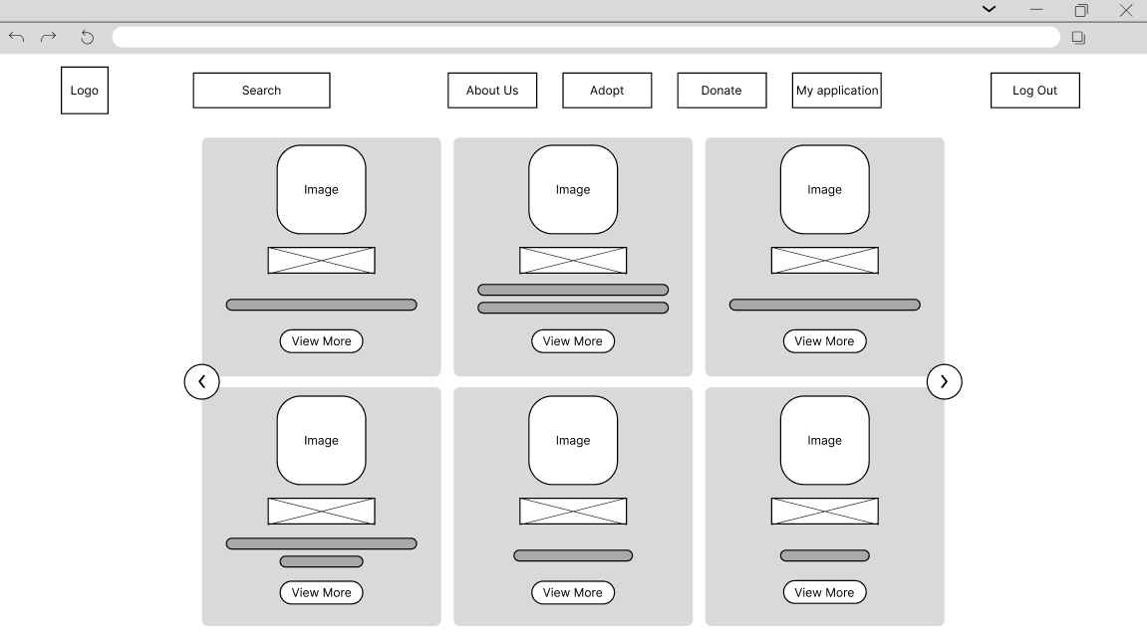

Adopt page shows basic information of dogs with their picture, User can click “View more” to see further information.

**Donate**

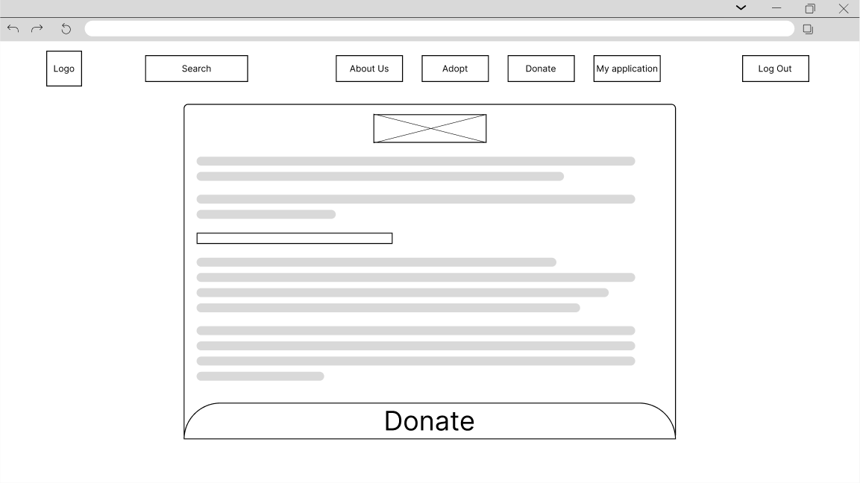

In the donate page, there will be brief explanation of reason of donations and how would it help.

### 2.4.3 Admin Interface

**Edit Dog Info**

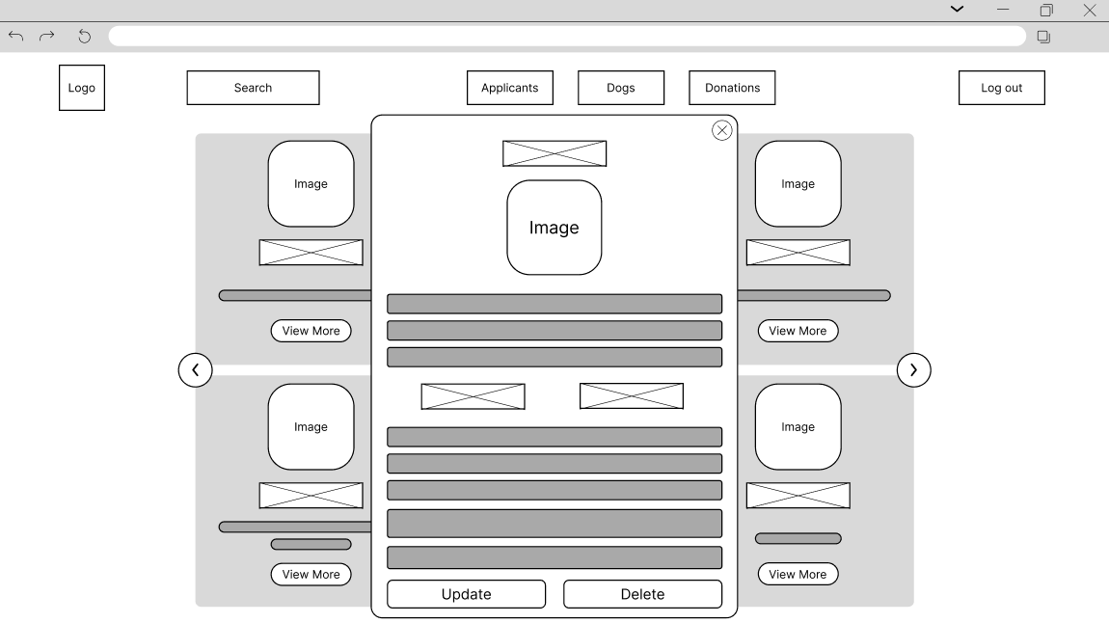

Admin can edit dogs information which include the image, name, description, breeds etc.

**View Applicants**

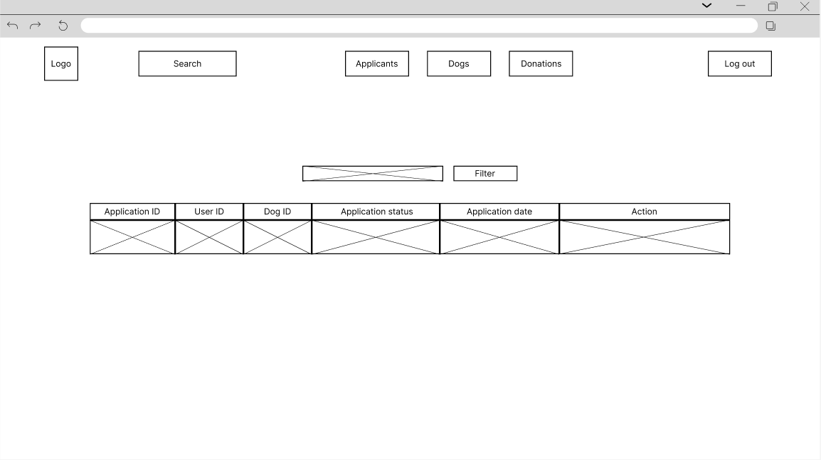

Admin can view applications made by user include details such as Application ID, User ID, Dog ID, Application status, date and action to reject or accept the application.

**Details Info**

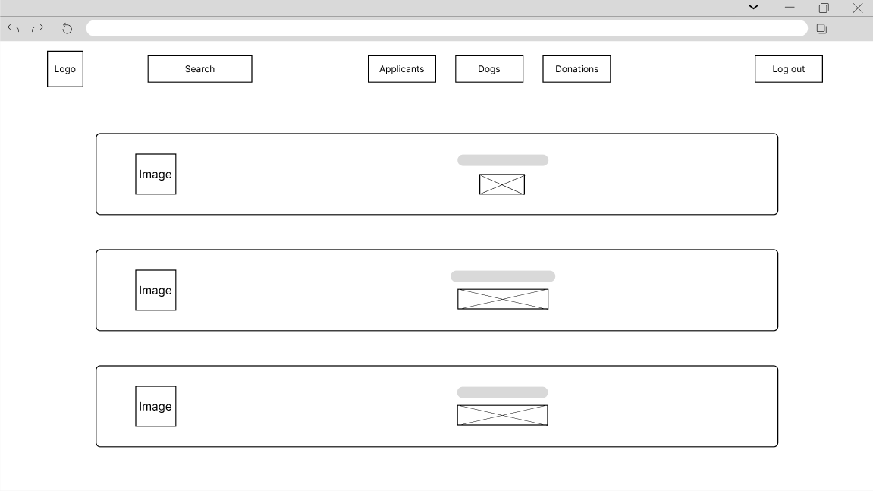

Admin can view summarize information in this page such as Total application, Total dog for Adoption and Total donations.

**Donation Details**

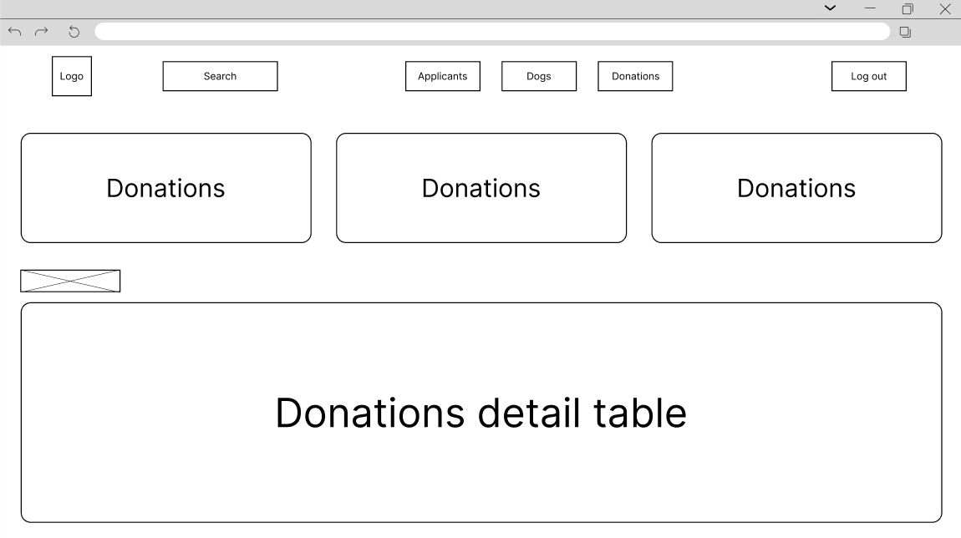

Admin can view all the donation info and transactio0n history in this page, the information includes total donation, Donor name, amount, and date.

# **3.0 IMPLEMENTATION**

## 3.1 Login and Sign in Page

<?php

    session_start();

function validate_ic($ic) {

    $regex = '/^[0-9]{6}-[0-9]{2}-[0-9]{4}$/';

    if (preg_match($regex, $ic)) {

        return true;

    } else {

        return false;

    }

}

include("connection.php");

if (isset($_POST['sign-up-button'])) {

    $username = $_POST['username'];

    $email = $_POST['useremail'];

    $password = $_POST['userpassword'];

    $usercontact = $_POST['usercontact'];

    $useric = $_POST['useric'];

    $useraddress = $_POST['useraddress'];

    $check_email_query = "SELECT * FROM user WHERE user_email = '$email'";

    $check_email_result = mysqli_query($con, $check_email_query);

    $existing_email_count = mysqli_num_rows($check_email_result);

    if ($existing_email_count > 0) {

        echo '<script type="text/javascript"> alert("Email already exists. Please use a different email.") </script>';

    } else if (!validate_ic($useric)) {

        echo '<script type="text/javascript"> alert("Invalid IC Number. Please enter a valid IC Number.") </script>';

    } else {

        $query = "INSERT INTO user (user_name, user_email, user_password, user_contact_number, ic_number, user_address)

        VALUES ('$username', '$email', '$password', '$usercontact', '$useric', '$useraddress')";

        $query_run = mysqli_query($con, $query);

        if ($query_run) {

            echo '<script type="text/javascript"> alert("User Registered") </script>';

        } else {

            die("Error: " . mysqli_error($con));

        }

    }

}

3.1.1 Sign Up

1. Initializing Session and IC Validation Function

session_start();Starts a session for storing user-related data across multiple pages.

function validate_ic($ic) Defines a function to validate IC Number input. It should be in this format (6 digits - 2 digits -4 digits).

1. Connect Database

include("connection.php") incorporates a separate file name “connection.php”. This file is responsible for connecting to the database in order to access the data.

1. Sign Up Form Submission

if (isset($_POST['sign-up-button' The code executes only when the "Sign Up" button is pressed, and the form is submitted.

Then it collects the user's input from the form fields and puts it in variables:

$username, $email, $password, $usercontact, $useric, and $useraddress

Constructs a query to search for the email in the user table.

Executes the query and counts the results.

if ($existing_email_count > 0) { This conditional block checks if the entered email already exists in the database

If exists:

* Alerts Email already exits and prompt user to use another email.

Else if:

* It invokes a function named validate_ic($useric) to check the authenticity of the IC number.

The code for this function isn't supplied, although it presumably enforces a specific format or

pattern. If the IC number is invalid, it warns the user.

Else:

* A SQL query named $query will insert all the users’ info into user table.
* $query_run = mysqli_query($con, $query);Executes the query with the previously created database connection and stores the result in the $query_run variable.
* If executes the query successfully
  + Alert “User Registered”
* Else:
  + Display error encountered for debugging purposes.

if (isset($_POST['sign-in-button'])) {

    $email = $_POST['useremail'];

    $password = $_POST['userpassword'];

    $sql = "SELECT * FROM user WHERE user_email = '$email' AND user_password = '$password'";

    $result = mysqli_query($con, $sql);

    $row = mysqli_fetch_array($result);

    $rowcount = mysqli_num_rows($result);

    if ($rowcount == 1) {

        $_SESSION['mySession'] = $row['user_id'];

        if ($row['user_email'] == 'admin@dogehub') {

            header("Location: homeadmin.php");

            exit();

        } else {

            header("Location: homeuser.php");

            exit();

        }

    } else {

        echo '<script type="text/javascript"> alert("Invalid Credentials. Please Try Again.") </script>';

    }

}

?>

3.1.2 Sign In

1. Sign in button

if (isset($_POST['sign-in-button'])) The code executes only when the "Sign In" button is pressed, and the form is submitted.

1. Execute query and Retrieve Data

$sql = "SELECT * FROM user WHERE user_email = '$email' AND user_password = '$password'";

This is a query which retrieve user password and user email from user table in database.

$result = mysqli_query($con, $sql); Executes the query with the previously created database connection and stores the result in the $result variable.

$row = mysqli_fetch_array($result); Retrieves the first row of the result set as an array and puts it in the $row variable.

$rowcount = mysqli_num_rows($result); Count the total number of rows in result variable and stores in $rowcount

1. Handle Result

if ($rowcount == 1) { This conditional block checks that the return set of the login query has exactly one entry.

If yes:

* User id will be stored in $_SESSION['mySession'] variable. Session is used to identify user.
* If user email = 'admin@dogehub'
  + Redirects user to homeadmin.php page which is an admin homepage.
* Else:
  + Redirects user to homeuser.php page which is a user homepage.

If no:

* Alert message is displayed to prompt users to enter email and password again.

<?php

  session_start();

  if (!isset($_SESSION['mySession'])){

    echo "<script>alert('You are not logged in');window.location.href='login.php';</script>";

  }

?>

This PHP code initiates a session and determines whether a certain session variable ('mySession') is set. If not, it shows a JavaScript notice that the user is not logged in and redirect them to the login page. This ensures that only logged-in users have access to the page.

3.1.3 Log Out

<?php

  session_start();

  session_destroy();

  echo "<script>alert('You are logged out');window.location.href='home.php';</script>";

?>

This PHP code creates a session, quickly destroys it with session_destroy(), and shows a JavaScript alert telling the user that they have logged out. Finally, the user is sent to the home.php page. This script efficiently logs out the user by terminating their session and redirecting them to the home page.

## 3.2 Admin View Donation Page

<?php

    include("connection.php");

    // Query to get the total amount of donation

    $query = "SELECT SUM(amount) AS total_donation FROM receipt";

    $result = mysqli_query($con, $query);

    // Check if the query was successful

    if ($result) {

        // Fetch the total donation amount

        $row = mysqli_fetch_assoc($result);

        $totalDonation = $row['total_donation'];

        // Display the total donation amount

        if ($totalDonation !== null) {

            $totalDonation = "$" . number_format($totalDonation, 2);

        } else {

            $totalDonation = "$" . number_format(0, 2);

        }

    } else {

        // Display donation as $0 if the table is empty

        echo "<h1>No Donation Thus Far</h1>";

        echo "Error: " . mysqli_error($con); // Add this line for debugging

}

?>

1. Connect Database

include("connection.php") incorporates a separate file name “connection.php”. This file is responsible for connecting to the database in order to access the data.

1. Retrieve total donations from database.

$query = "SELECT SUM(amount) AS total_donation FROM receipt"; . This is a SQL query which calculates the sum of every donation amount (total amount) in database.

$result = mysqli_query($con, $query); Executes the query with the previously created database connection and stores the result in the $result variable.

1. Handling query results

if ($result) This conditional block checks if the query was successful

if successful:

* $row = mysqli_fetch_assoc($result); Retrieves the single row in the result set that contains the computed total donation.
* $totalDonation = $row['total_donation']; Retrieves “total_donation” value from the fetched row and stores in $totalDonation variable.
* Determines whether $totalDonation is not null. If not, the value is formatted as a currency string with two decimal places by number_format(). Otherwise, it sets $totalDonation to zero.

If unsuccessful:

* Display No Donation Thus Far
* Display error encountered for debugging purposes

<?php

                    include("connection.php");

                    $sql = "SELECT receipt.user_id, receipt.amount, receipt.timestamp, user.user_name

                            FROM receipt

                            INNER JOIN user ON receipt.user_id = user.user_id

                            ORDER BY receipt.timestamp DESC LIMIT 10";

                    $result = mysqli_query($con, $sql);

                    if (mysqli_num_rows($result) > 0) {

                        $rowNumber = 1;

                        while($row = mysqli_fetch_assoc($result)) {

                            echo "<tr>

                                    <td>$rowNumber</td>

                                    <td>".$row["user_name"]."</td>

                                    <td> $ ".$row["amount"]."</td>

                                    <td>".$row["timestamp"]."</td>

                                </tr>";

                            $rowNumber++;

                        }

                    } else {

                        echo '<h1 style="text-align:center;">There are no donations :(</h1><br>';

                    }

?>

1. Connect Database

include("connection.php") incorporates a separate file name “connection.php”. This file is responsible for connecting to the database in order to access the data.

1. Retrieve Recent Donations Data

$sql = "SELECT receipt.user_id, receipt.amount, receipt.timestamp, user.user_name FROM receipt INNER JOIN user ON receipt.user_id = user.user_id ORDER BY receipt.timestamp DESC LIMIT 10";

Retrieves data listed above from receipt and user table (links and combines both tables using user_id) and arrange the results in descending order based on the timestamp column. Restricts the results to the 10 most recent donations

1. Execute query and handle results

$result = mysqli_query($con, $sql); Executes the query with the previously created database connection and stores the result in the $result variable.

if (mysqli_num_rows($result) > 0) This conditional block checks if the query retrieves any data

If yes:

* while($row = mysqli_fetch_assoc($result)) { echo "<tr>

<td>$rowNumber</td> ……….

$rowNumber++;

While function iterates through each row of the result and generates html tables using </td> to display donation information. Row number, user name, amount and time are displayed in the table.

If No:

* Print “there are no donations”.

## 3.3 User Donate Page

<?php

include("session.php");

?>

The PHP code at the top includes a file named "session.php" using the include() function.

This PHP code starts a session using session_start() and checks if a session variable named 'mySession' is set. If it's not set, meaning the user is not logged in, it displays an alert message "You are not logged in" and redirects the user to the login page login.php using JavaScript.

3.3.1 Insert Data into Database

            <form action="donateinsert.php" method="post">

This line sets up a form that, when submitted, sends data to "donateinsert.php" using the HTTP POST method.

3.3.2 Select Donation Amount

<div id="donation-amounts">

                    <h1 class="header">Donate Amount</h1>

                    <!-- Donation amount selection inputs -->

                    <input type="radio" id="amount-10" name="donation_amount" value="10" onchange="proceedToPayment()">

                    <label for="amount-10">RM10</label><br>

                    <input type="radio" id="amount-50" name="donation_amount" value="50" onchange="proceedToPayment()">

                    <label for="amount-50">RM50</label><br>

                    <input type="radio" id="amount-100" name="donation_amount" value="100" onchange="proceedToPayment()">

                    <label for="amount-100">RM100</label><br>

**1. Donation amount selection inputs:**

Three radio input elements are provided with different values (RM10, RM50, RM100), allowing users to choose preset donation amounts.

**2. Call Function to proceed payment**

onchange="proceedToPayment()"

The proceedToPayment() function is called whenever a radio input is changed. It calculates the selected donation amount and updates the display accordingly.

function proceedToPayment() {

    var selectedAmount;

    var customAmountRadio = document.getElementById('amount-custom-radio');

    var customAmountInput = document.getElementById('custom-amount-input');

    if (customAmountRadio.checked) {

        selectedAmount = customAmountInput.value;

    } else {

        selectedAmount = document.querySelector('input[name="donation_amount"]:checked').value;

    }

    document.getElementById('selected-amount').textContent = 'Selected amount: RM' + selectedAmount;

    document.getElementById('donation-amounts').style.display = 'none';

    document.getElementById('payment-methods').style.display = 'block';

}

The JavaScript function `proceedToPayment()` handles the selection of donation amounts in the HTML interface. It retrieves the chosen amount, either from a custom input field for user-defined amounts or from the checked radio input for preset amounts. Subsequently, it displays the selected amount to the user and toggles the visibility of interface elements, hiding the donation amount selection interface ('donation-amounts') while revealing the payment methods section ('payment-methods').

3.3.3 Custom Donation Amount

<input type="radio" id="amount-custom-radio" name="donation_amount" value="custom">

                    <label for="amount-custom-radio">Custom amount: RM</label>

                    <input type="text" id="custom-amount-input" name="custom_donation_amount" placeholder="Enter amount">

                    <br><button type="button" id="amount-custom-button">Enter</button>

1. Custom Amount

<input type="radio" id="amount-custom-radio" name="donation_amount" value="custom">

allows the user to select a custom donation amount. Its value is set to "custom" to differentiate it from preset donation amounts.

<label for="amount-custom-radio">Custom amount: RM</label> provides a description for the custom donation amount input field.

<input type="text" id="custom-amount-input" name="custom_donation_amount" placeholder="Enter amount"> allows the user to enter a custom donation amount.

2. Submit and Trigger Validation

<button type="button" id="amount-custom-button">Enter</button> triggers the validation of the custom donation amount entered by the user.

function validateDonationAmount() {

    var customAmountInput = document.getElementById('custom-amount-input');

    var customAmount = parseFloat(customAmountInput.value);

    // Check if a donation amount is selected

    var selectedAmount = document.querySelector('input[name="donation_amount"]:checked');

    if (!selectedAmount) {

        alert('Please select a donation amount.');

        return false;

    }

    // If custom amount is selected, validate it

    if (selectedAmount.value === 'custom') {

        if (isNaN(customAmount) || customAmount <= 10) {

            alert('Please enter a donation amount greater than RM10.');

            customAmountInput.value = ''; // Clear the input field

            customAmountInput.focus(); // Set focus back to the input field

            return false; // Return false to indicate validation failure

        }

    }

    return true; // Return true to indicate validation success

}

1. Variables

var customAmountInput = document.getElementById('custom-amount-input'); retrieves the HTML input element with the ID "custom-amount-input" and stores it in the variable customAmountInput.

var customAmount = parseFloat(customAmountInput.value); converts the value entered in the custom amount input field to a floating-point number using the parseFloat() function and stores it in the variable customAmount.

var selectedAmount = document.querySelector('input[name="donation_amount"]:checked'); selects the checked radio input element with the name "donation_amount" using the document.querySelector() method and stores it in the variable selectedAmount. This variable will hold the selected donation amount.

2. If Donation not selected

if (!selectedAmount) {

        alert('Please select a donation amount.');

        return false;

This condition determines if no donation amount is selected (i.e., if selectedAmount is false). If no amount is specified, it shows an alert message asking the user to choose a contribution amount and returns false to signal validation failure.

3. Validate Amount

if (selectedAmount.value === 'custom') {

        if (isNaN(customAmount) || customAmount <= 10) {

            alert('Please enter a donation amount greater than RM10.');

            customAmountInput.value = ''; // Clear the input field

            customAmountInput.focus(); // Set focus back to the input field

            return false; // Return false to indicate validation failure

        }

    }

    return true; // Return true to indicate validation success

}

This condition determines whether the specified donation amount is the custom option. If so, it validates the custom amount donated by the user. If the custom amount is not a number (NaN), or if it is less than or equal to RM10, a warning notice appears, asking the user to submit a larger contribution amount. It also clears the input field and returns focus to it. If the requirements are not satisfied, it turns false, indicating that validation has failed. This line is reached if all validation checks pass. It returns true to indicate that the custom donation amount is valid, and the validation was successful.

3.3.4 Select Payment Method

<div class="payment-option">

                        <input type="radio" id="touch-n-go-option" name="payment_method" value="touch-n-go" onchange="displayPaymentDetails(this.value)" required>

                        <label for="touch-n-go-option">Touch'N Go/Duitnow</label>

                        <div class="qr-icons">

                            <img src="Images/TNG.png" alt="TNG Icon" style="height: 25px;width: 25px;">

                            <img src="Images/Duitnow.png" alt="Duitnow Icon" style="height: 25px;width: 25px;">

                        </div>

                    </div>

                    <hr>

                    <div class="payment-option">

                        <input type="radio" id="bank-transfer-option" name="payment_method" value="bank-transfer" onchange="displayPaymentDetails(this.value)" required>

                        <label for="bank-transfer-option">Bank Transfer</label>

                        <div class="bank-icons">

                            <img src="Images/bank.png" alt="BANK Icon" style="height: 25px;width: 120px;">

                        </div>

                    </div>

1. Call function to Payment Details

onchange="displayPaymentDetails(this.value)" required>

Both radio inputs in the HTML code include an onchange attribute, which calls a JavaScript function called displayPaymentDetails(this.value) when the user picks a new payment option. This function is meant to dynamically display extra payment details based on the selected choice. Furthermore, both entries are marked as necessary, requiring the user to choose one of the payment alternatives before proceeding with the form submission.

function displayPaymentDetails(value) {

    // Hide all payment details sections

    var paymentDetails = document.getElementsByClassName('payment-details');

    for (var i = 0; i < paymentDetails.length; i++) {

        paymentDetails[i].style.display = 'none';

    }

    // Hide all payment options

    var paymentOptions = document.getElementsByClassName('payment-option');

    for (var i = 0; i < paymentOptions.length; i++) {

        paymentOptions[i].style.display = 'none';

    }

    // Show the selected payment details section

    document.getElementById(value + '-details').style.display = 'block';

    // Show the selected payment option

    document.getElementById(value + '-option').style.display = 'block';

}

1. Hide All Payment Details and Option

var paymentDetails = document.getElementsByClassName('payment-details');

    for (var i = 0; i < paymentDetails.length; i++) {

        paymentDetails[i].style.display = 'none';

}

This code retrieves elements with the class "payment-details" and hides them by setting their display style to 'none'.

var paymentOptions = document.getElementsByClassName('payment-option');

    for (var i = 0; i < paymentOptions.length; i++) {

        paymentOptions[i].style.display = 'none';

    }

This code retrieves elements with the class "payment-option" and hides them by setting their display style to 'none'.

2. Show Selected Payment Details and Option only

document.getElementById(value + '-details').style.display = 'block';

 document.getElementById(value + '-option').style.display = 'block';

These lines display both the payment details section and the selected payment option. They use document.getElementById() to select the elements by their IDs, which are determined by concatenating the value with '-details' and '-option', and then set their display style to 'block', making them visible.

3.3.5 Back Function

function goBackToDonation() {

    document.getElementById('donation-amounts').style.display = 'block';

    document.getElementById('payment-methods').style.display = 'none';

}

1. Back to Donation Amount

goBackToDonation(), controls the visibility of the donation amounts and payment methods sections. It changes the display style of the 'donation-amounts' part to 'block', making it visible, and hides the 'payment-methods' section by changing its display style to 'none'.

function goBackToPaymentOptions() {

    // Hide all payment details sections

    var paymentDetails = document.getElementsByClassName('payment-details');

    for (var i = 0; i < paymentDetails.length; i++) {

        paymentDetails[i].style.display = 'none';

    }

    // Show all payment options

    var paymentOptions = document.getElementsByClassName('payment-option');

    for (var i = 0; i < paymentOptions.length; i++) {

        paymentOptions[i].style.display = 'block';

    }

}

2. Back to Payment Method

goBackToPaymentOptions() controls the return to the payment options section. It hides all payment information parts while displaying all payment choices sections. It accomplishes this by iterating over items with the class 'payment-details' and adjusting their display style to 'none', therefore effectively hiding them. Then, it iterates over items with the class 'payment-option' and changes their display style to 'block', making them visible.

3.3.6 Submit Donation

<button type="submit" name="submit_button">Submit</button>

if(isset($_POST['submit_button'])){

    include("connection.php");

    // Get the current timestamp

    $timestamp = time();

    // Get the selected donation amount

    $donationAmount = $_POST['donation_amount'];

1. Check submitted form

if(isset($_POST['submit_button'])){ checks if the form has been submitted by checking if the 'submit_button' parameter is present in the POST request.

2. Connect Database

include("connection.php") incorporates a separate file name “connection.php”. This file is responsible for connecting to the database in order to access the data.

3. Retrieve Timestamp

$timestamp = time (); retrieves the current timestamp using the time() function and stores it in the variable $timestamp.

4. Retrieve Donation Amount

$donationAmount = $_POST['donation_amount']; retrieves the selected donation amount from the form submission and stores it in the variable $donationAmount.

if ($donationAmount === 'custom') {

        $customAmount = $_POST['custom_donation_amount'];

        // Insert the custom donation amount into the database

        $sql = "INSERT INTO receipt (user_id, amount, timestamp, payment_method)

                VALUES ($_SESSION[mySession], '$customAmount', '$timestamp', '$_POST[payment_method]')";

    } else {

        // Insert the selected donation amount into the database

        $sql = "INSERT INTO receipt (user_id, amount, timestamp, payment_method)

                VALUES ($_SESSION[mySession], '$donationAmount', '$timestamp', '$_POST[payment_method]')";

    }

1. Check Custom Amount

if ($donationAmount === 'custom') { check whether the donation is customized or not.

If yes $customAmount = $_POST['custom_donation_amount']; retrieves the custom donation amount value from the form submission and stores it in the variable $customAmount

2. Insert Query Database for Custom Donation

$sql = "INSERT INTO receipt (user_id, amount, timestamp, payment_method)

                VALUES ($_SESSION[mySession], '$customAmount', '$timestamp', '$_POST[payment_method]')";

These lines construct an SQL query to insert the donation details into the database table "receipt".Depending on whether the donation amount is custom or preset, it inserts either the custom amount or the preset amount, along with other details such as user ID ($_SESSION['mySession']), timestamp, and payment method ($_POST['payment_method']).

3. IF not custom

} else {

        // Insert the selected donation amount into the database

        $sql = "INSERT INTO receipt (user_id, amount, timestamp, payment_method)

                VALUES ($_SESSION[mySession], '$donationAmount', '$timestamp', '$_POST[payment_method]')";

    }

These lines construct an SQL query to insert the donation details into the database table "receipt".In this case, it inserts the preset donation amount (stored in $donationAmount) along with other details such as user ID ($_SESSION['mySession']), timestamp, and payment method ($_POST['payment_method']).

if (!mysqli_query($con, $sql)) {

        die('Error: ' . mysqli_error($con));

    } else {

        // Redirect the user after successful donation

        echo "<script>alert('Thank you for your donation!');window.location.href='donateuser.php';</script>";

    }

1. Donation Unsuccessful

if (!mysqli_query($con, $sql)) {

        die('Error: ' . mysqli_error($con));

This line executes the SQL query using the mysqli_query() function, passing in the database connection $con and the SQL query $sql. If the query execution fails, it outputs an error message and terminates the script.

2. Donation Success

} else {

        // Redirect the user after successful donation

        echo "<script>alert('Thank you for your donation!');window.location.href='donateuser.php';</script>";

    }

If the query execution is successful, this line displays a JavaScript alert to thank the user for their donation and then redirects them to the "donateuser.php" page.

} else {

    // Handle case where form is not submitted

    echo "<script>alert('Error: Please submit the form');window.location.href='donateuser.php';</script>";

}

?>

1. Form not submitted

echo "<script>alert('Error: Please submit the form');window.location.href='donateuser.php';</script>";

}

If the form has not been submitted, this line handles the case by displaying an error alert and redirecting the user back to the "donateuser.php" page.

## 3.4 Adopt Page

<?php

include("session.php");

?>

The PHP code at the top includes a file named "session.php" using the include() function.

This PHP code starts a session using session_start() and checks if a session variable named 'mySession' is set. If it's not set, meaning the user is not logged in, it displays an alert message "You are not logged in" and redirects the user to the login page login.php using JavaScript.

**3.4.1 Admin add more dogs**

<?php

include("connection.php");

$sql = "SELECT * FROM dog ";

if(isset($_POST['search-function'])) {

$searchName = $_POST['searchName'];

$sql = "SELECT * FROM dog WHERE dog_name LIKE '%$searchName%'";

}

$result = mysqli_query($con, $sql);

?>

1. Include Database Connection:

include("connection.php");

This line includes the file "connection.php", which likely contains code to establish a connection to the database. This is necessary to interact with the database in subsequent queries.

2. Query Database for Dog Records:

$sql = "SELECT * FROM dog ";

This line sets up a SQL query to select all columns (*) from the table named "dog". This query fetches all records from the "dog" table.

3. Check for Search Functionality:

if(isset($_POST['search-function'])) {

This condition checks if the form with the name "search-function" has been submitted. This suggests that there's likely a form on the webpage with a field named "searchName" where users can input a search query.

4. Retrieve Search Query and Modify SQL Query:

$searchName = $_POST['searchName'];

$sql = "SELECT * FROM dog WHERE dog_name LIKE '%$searchName%'";

If the search form has been submitted, this code retrieves the search query from the POST request. It then modifies the SQL query to include a WHERE clause that filters records based on the dog's name (dog_name) matching the search query. The LIKE keyword allows for partial matches, and the % symbols indicate wildcards (i.e., any characters before or after the search query).

5. Execute SQL Query:

$result = mysqli_query($con, $sql);

This line executes the SQL query using the mysqli_query() function, passing in the database connection ($con) and the SQL query. The result of the query execution is stored in the variable $result, which can be further processed to fetch data from the database.

**3.4.2 dog-info-update/delete**

<?php

echo '<form class="formviewmore" action="update.php" method="post" enctype="multipart/form-data" style=width:600px;>';

echo '<h1>Dog Info</h1>';

echo '<img class="view_image" src="uploads_dogimage/'.$row_view['dog_image'].'" alt="Beagle" draggable="false">';

echo '<input type="hidden" name="dogid" value="' . $row_view['dog_id'] . '">';

echo '<input type="text" name="dogname" placeholder="Dog Name"value="' . $row_view['dog_name'] . '" required>';

echo '<input type="text" name="dogBreed" value="' . $row_view['breed'] . '" required>';

echo '<input type="date" name="dob" value="' . $row_view['DOB'] . '" required>';

echo '<div class="radios">';

echo '<p>Male</p>';

echo '<input type="radio" name="gender" value="Male" required ' . ($row_view['gender'] == 'Male' ? 'checked' : '') . '>';

echo '<p>Female</p>';

echo '<input type="radio" name="gender" value="Female" required ' . ($row_view['gender'] == 'Female' ? 'checked' : '') . '>';

echo '</div>';

echo '<input type="text" name="dogColor" value="' . $row_view['color'] . '" required>';

echo '<input type="text" name="dogWeight" value="' . $row_view['dog_weight'] . '" required>';

echo '<input type="select" name="dogStatus" value="' . $row_view['adoption_status'] . '" required>';

echo '<textarea name="desc">' . $row_view['dog_description'] . '</textarea><br>';

echo '<input type="file" name="dog_image" required><br>';

echo '<button type="submit" name="update" class="addmorebtn">Update</button>';

echo '</form>'; // Close the form tag here

echo '<a class="delete" onclick="return confirm(\'Are you sure you want to delete this record ? \')" href="delete.php?dog_id='.$row_view['dog_id'].'">

<button class="delbtn">Delete</button></a>';

}

?>

**1. Form Setup:**

echo '<form class="formviewmore" action="update.php" method="post" enctype="multipart/form-data" style=width:600px;>';

This line starts the HTML form for displaying detailed information about the dog. The form is set to submit to "update.php" upon submission.

**2. Dog Information Display:**

echo '<h1>Dog Info</h1>';

This line outputs a heading indicating that the displayed information is about the dog.

**3. Dog Image Display:**

echo '<img class="view_image" src="uploads_dogimage/'.$row_view['dog_image'].'" alt="Beagle" draggable="false">';

This line displays the dog's image. The image source is fetched from the "uploads_dogimage" directory, and the image filename is retrieved from the database.

1. **Hidden Input for Dog ID:**

echo '<input type="hidden" name="dogid" value="' . $row_view['dog_id'] . '">';

This line includes a hidden input field to store the dog's ID. This ID is crucial for identifying the dog record to update when the form is submitted.

1. **Input Fields for Dog Details:**

These lines output various input fields pre-filled with the dog's details retrieved from the database, such as name, breed, date of birth, gender, color, weight, adoption status, and description.

1. **Submit Button for Update:**

echo '<button type="submit" name="update" class="addmorebtn">Update</button>';

This line outputs a submit button that, when clicked, submits the form to "update.php". This button is likely used to update the dog record with any changes made in the form.

1. **Delete Button:**

echo '<a class="delete" onclick="return confirm(\'Are you sure you want to delete this record ? \')" href="delete.php?dog_id='.$row_view['dog_id'].'"> <button class="delbtn">Delete</button></a>';

This line outputs a delete button that allows the user to delete the current dog record. It triggers a confirmation dialog to ensure the user wants to proceed with the deletion.

**3.4.3 User Adoption Application Submission**

<?php

include("session.php");

if (isset($_POST['adoptnow'])) {

include("connection.php");

// Check if the user has a pending adoption application for the selected dog

$userId = $_SESSION['mySession'];

$dogId = $_POST['dogid'];

$checkSql = "SELECT * FROM adoption_application WHERE user_id = '$userId' AND dog_id = '$dogId' AND application_status = 'Pending'";

$checkResult = mysqli_query($con, $checkSql);

if (mysqli_num_rows($checkResult) > 0) {

// User has already submitted an application for the selected dog

echo "<script>alert('You have already submitted an adoption application for this dog.');window.location.href='adoptuser.php';</script>";

} else {

// User can proceed to submit a new application

$date = date('Y-m-d H:i:s');

$sql = "INSERT INTO adoption_application (

user_id,

dog_id,

application_status,

application_date

)

VALUES (

'$userId',

'$dogId',

'Pending',

'$date')";

if (!mysqli_query($con, $sql)) {

die('Error: ' . mysqli_error($con));

} else {

echo "<script>alert('Your application will be processed!');window.location.href='adoptuser.php';</script>";

}

}

} else {

echo "<script>alert('Error: Please submit the form');window.location.href='adoptuser.php';</script>";

}

?>

1. **Including Necessary Files:**

include("session.php");

The code begins by including the **session.php** file, which starts the session and ensures that the user is logged in.

It checks if the form for submitting the adoption application has been submitted.

1. **Checking for Existing Application**:

$userId = $_SESSION['mySession'];

$dogId = $_POST['dogid'];

$checkSql = "SELECT * FROM adoption_application WHERE user_id = '$userId' AND dog_id = '$dogId' AND application_status = 'Pending'";

$checkResult = mysqli_query($con, $checkSql);

The code retrieves the user's ID from the session and the dog's ID from the submitted form.

It constructs an SQL query to check if the user already has a pending adoption application for the selected dog.

The query is executed, and if there are any rows returned, it means the user has already applied to that dog. In this case, an alert is shown, informing the user that they have already applied for adoption.

1. **Submitting New Application**:

$sql = "INSERT INTO adoption_application (

user_id,

dog_id,

application_status,

application_date

)

VALUES (

'$userId',

'$dogId',

'Pending',

'$date')";

If the user does not have a pending application for the selected dog, a new application is submitted.

The current date and time are obtained and formatted.

An SQL **INSERT** query is constructed to insert a new row into the **adoption_application** table with the user's ID, dog's ID, application status set to "Pending," and the current date and time.If the query execution is successful, a success message is displayed, informing the user that their application will be processed.If there is an error during the query execution, an error message is displayed.

* + 1. Admin manages of adoption applications

<?php

include("connection.php");

$sql = "SELECT * FROM adoption_application WHERE application_status = 'pending' OR application_status = 'rejected'";

if(isset($_POST['filterbutton'])) {

$filter = $_POST['filter'];

if($filter != "all") {

$sql = "SELECT * FROM adoption_application WHERE application_status = '$filter'";

}

}

$result = mysqli_query($con, $sql);

if (mysqli_num_rows($result) > 0) {

while($row = mysqli_fetch_assoc($result)) {

$statusClass = strtolower($row["application_status"]);

// Convert status to lowercase for consistency in class names

echo "<tr>

<td>".$row["application_id"]."</td>

<td>".$row["user_id"]."</td>

<td>".$row["dog_id"]."</td>

<td><div><p class='$statusClass'>".$row["application_status"]."</p></div></td>

<td>".$row["application_date"]."</td>

<td>

<form method='post' action='updateapplicant.php'>

<input type='hidden' name='application_id' value='".$row['application_id']."'>

<input type='hidden' name='dog_id' value='".$row['dog_id']."'>

<button type='submit' name='approvebutton' class='approvebutton'>Approve</button>

<button type='submit' name='rejectbutton' class='rejectbutton'>Reject</button>

</form>

</tr>";

}

} else {

echo '<h1 style=text-align:center;>There are no applicants.</h1><br>';

}

mysqli_close($con);

?>

1. **Construct SQL Query:**

$sql = "SELECT * FROM adoption_application WHERE application_status = 'pending' OR application_status = 'rejected'";

**Here, an SQL query is constructed to select all adoption applications with the status "pending" or "rejected" from the database.**

1. **Execute SQL Query:**

$result = mysqli_query($con, $sql);

This line executes the SQL query and stores the result in the variable $result.

1. **Display Application Data:**

if (mysqli_num_rows($result) > 0) {

while($row = mysqli_fetch_assoc($result)) {

else {

echo '<h1 style=text-align:center;>There are no applicants. .</h1><br>';

This part checks if there are any rows returned by the query. If there are, it loops through each row and displays the application details in a table row. If there are no applicants, it displays a message indicating so.

1. **Close Database Connection:**

mysqli_close($con);

**This line closes the database connection to free up resources.**

* + 1. **filtering based on the application status**

<?php

include("connection.php");

$login_id = $_SESSION['mySession'];

$sql = "SELECT * FROM adoption_application

INNER JOIN dog ON adoption_application.dog_id = dog.dog_id

WHERE user_id = '$login_id';";

if(isset($_POST['filterbutton'])) {

$filter = $_POST['filter'];

if($filter != "all") {

$sql = "SELECT * FROM adoption_application

INNER JOIN dog ON adoption_application.dog_id = dog.dog_id

WHERE user_id = '$login_id' AND application_status='$filter';";

}

}

$result = mysqli_query($con, $sql);

?>

1. **Retrieve User ID:**

$login_id = $_SESSION['mySession'];

This line retrieves the user ID of the currently logged-in user from the session variable.

1. **Construct SQL Query:**

$sql = "SELECT * FROM adoption_application

INNER JOIN dog ON adoption_application.dog_id = dog.dog_id

WHERE user_id = '$login_id';";

This SQL query selects all columns from the adoption_application table and the dog table using an inner join on the dog_id column. It retrieves rows where the user_id matches the user ID of the currently logged-in user.

1. **Apply Filtering:**

if(isset($_POST['filterbutton'])) {

$filter = $_POST['filter'];

if($filter != "all") {

$sql = "SELECT * FROM adoption_application

INNER JOIN dog ON adoption_application.dog_id = dog.dog_id

WHERE user_id = '$login_id' AND application_status='$filter';";

}

}

If the filter button is pressed (identified by isset($_POST['filterbutton'])), this block of code modifies the SQL query to include a filter based on the application status. If the selected filter is not "all", it adds a condition to the WHERE clause to only select rows where the application status matches the selected filter.

1. **Execute SQL Query:**

$result = mysqli_query($con, $sql);

This line executes the constructed SQL query using the database connection established earlier and stores the result in the $result variable.

* + 1. **Cancellation of an adoption application**

<?php

if (!isset($_POST['cancel_button'])) {

echo "<script>alert('Error: Please submit the form');window.location.href='applicantuser.php';</script>";

} else {

include("connection.php");

$application_id = $_POST['application_id'];

$sql = "DELETE FROM adoption_application WHERE application_id = '$application_id'";

if (!mysqli_query($con, $sql)) {

die('Error: ' . mysqli_error($con));

} else {

echo "<script>alert('Your application has been cancelled!');window.location.href='applicantuser.php';</script>";

}

}

1. **Check for Form Submission:**

if (!isset($_POST['cancel_button'])) {

echo "<script>alert('Error: Please submit the form');window.location.href='applicantuser.php';</script>";

} else {

This part checks if the cancel button was pressed and the form was submitted. If not, it displays an error message and redirects the user back to the applicantuser.php page.

1. **Cancellation Process:**

include("connection.php");

$application_id = $_POST['application_id'];

$sql = "DELETE FROM adoption_application WHERE application_id = '$application_id'";

if (!mysqli_query($con, $sql)) {

die('Error: ' . mysqli_error($con));

} else {

echo "<script>alert('Your application has been cancelled!');window.location.href='applicantuser.php';</script>";

}

}

If the cancel button was pressed and the form was submitted, this part includes the connection.php file to establish a database connection. It then retrieves the application ID from the submitted form data ($_POST['application_id']) and constructs a SQL DELETE query to remove the corresponding record from the adoption_application table. If the query execution fails, it outputs an error message. Otherwise, it displays a success message and redirects the user back to the applicantuser.php page.

* + 1. **Deletion of a dog record**

<?php

include("connection.php");

if (isset($_GET['dog_id'])){

$id = $_GET['dog_id'];

$sql = "DELETE FROM dog WHERE dog_id = $id";

$result = mysqli_query($con,$sql);

mysqli_close($con);

echo "<script>alert('Dog deleted');window.location.href='admindogs.php'</script>";

}

else {

echo "<script>alert('Please select a dog to delete!');window.location.href='admindogs.php';</script>";

}

?>

1. **Check for Dog ID:**

if (isset($_GET['dog_id'])){

This part checks if a dog ID is provided in the URL query parameters ($_GET['dog_id']). If a dog ID is present, it proceeds with the deletion process. Otherwise, it displays an error message indicating that no dog has been selected.

1. **Deletion Process:**

$id = $_GET['dog_id'];

$sql = "DELETE FROM dog WHERE dog_id = $id";

$result = mysqli_query($con,$sql);

mysqli_close($con);

Inside the block where a dog ID is provided, this code segment retrieves the dog ID from the URL query parameters ($_GET['dog_id']). It then constructs a SQL DELETE query to remove the dog record from the database table "dog" based on the provided ID. After executing the query, it closes the database connection.

1. **Handling Deletion Result:**

echo "<script>alert('Dog deleted');window.location.href='admindogs.php'</script>";

After successfully deleting the dog record, this code segment displays an alert message indicating that the dog has been deleted and redirects the user back to the admindogs.php page.

4. Handling No Dog ID Provided:

echo "<script>alert('Please select a dog to delete!');window.location.href='admindogs.php';</script>";

If no dog ID is provided in the URL parameters, this code segment displays an error alert message indicating that the user needs to select a dog to delete and redirects them back to the admindogs.php page. (w3school, 2022)

## 3.5 Admin Add Dogs Page

<?php

  if(isset($_POST['addmore_button'])){

    include("connection.php");

    $dogId = mysqli_insert_id($con);

    $target_dir = "uploads_dogimage/";

    $target_file = $target_dir . basename($_FILES["dog_image"]["name"]);

    if (move_uploaded_file($_FILES["dog_image"]["tmp_name"], $target_file)) {

        echo "The file ". basename( $_FILES["dog_image"]["name"]). " has been uploaded.";

        $file_name = basename($_FILES["dog_image"]["name"]);

        $sql = "INSERT INTO dog (

          dog_name,

          breed,

          DOB,

          gender,

          color,

          dog_weight,

          adoption_status,

          dog_description,

          dog_image

          )

         VALUES (

          '$_POST[dogname]',

          '$_POST[dogBreed]',

          '$_POST[dob]',

          '$_POST[gender]',

          '$_POST[dogColor]',

          '$_POST[dogWeight]',

          'Available',

          '$_POST[desc]',

          '".$file_name."')";

        if (!mysqli_query($con,$sql))

          {

            die('Error: ' . mysqli_error($con));

      }

        else{

          echo "<script>alert('Dog information added successfully!');window.location.href='admindogs.php';</script>";

        }

        }

      else{

        echo "<script>alert('Please fill in the form!');window.location.href='admindogs.php';</script>";

      }

    } else {

        echo "Sorry, there was an error uploading your file.";

    }

?>

1. Check form submission.

if(isset($_POST['addmore_button']) The code executes only when the “add more” button is pressed, and the form is submitted

1. Connect database and upload image

include("connection.php") incorporates a separate file name “connection.php”. This file is responsible for connecting to the database in order to access the data.

* If submitted:
  + Includes the "connection.php" file to establish a database connection.
  + Retrieves the last inserted ID using mysqli_insert_id($con), likely for assigning a unique dog ID.
  + Defines the upload directory for dog images ("uploads_dogimage/").
  + Constructs a target file path combining the directory and uploaded file name.
  + Attempts to move the uploaded image file (dog_image) to the target location using move_uploaded_file.
  + Displays a success message if the upload is successful. Otherwise, shows an error message.

1. Insert Data

* If image upload is successful:
  + Extracts the uploaded image filename (basename($_FILES["dog_image"]["name"])).
  + Constructs an SQL query to insert a new dog record into the "dog" table.
  + The query includes dog information from the form ($_POST) and the uploaded image filename.
  + Executes the query using mysqli_query($con, $sql).
  + Displays a success message and redirects to the "admindogs.php" page if the query is successful. Otherwise, displays an error message and redirects to the same page.

1. Error Handling

else {

echo "Sorry, there was an error uploading your file.";

If a problem occurs when uploading the file, a generic error message will be displayed.

## 3.6 Admin Applicants Page

<?php

            include("connection.php");

            $sql = "SELECT * FROM adoption_application WHERE application_status = 'pending' OR application_status = 'rejected'";

            if(isset($_POST['filterbutton'])) {

              $filter = $_POST['filter'];

              if($filter != "all") {

                $sql = "SELECT * FROM adoption_application WHERE application_status = '$filter'";

              }

            }

            $result = mysqli_query($con, $sql);

            if (mysqli_num_rows($result) > 0) {

              while($row = mysqli_fetch_assoc($result)) {

                $statusClass = strtolower($row["application_status"]);

                // Convert status to lowercase for consistency in class names

                echo "<tr>

                  <td>".$row["application_id"]."</td>

                  <td>".$row["user_id"]."</td>

                  <td>".$row["dog_id"]."</td>

                  <td><div><p class='$statusClass'>".$row["application_status"]."</p></div></td>

                  <td>".$row["application_date"]."</td>

                  <td>

                    <form method='post' action='updateapplicant.php'>

                      <input type='hidden' name='application_id' value='".$row['application_id']."'>

                      <input type='hidden' name='dog_id' value='".$row['dog_id']."'>

                      <button type='submit' name='approvebutton' class='approvebutton'>Approve</button>

                      <button type='submit' name='rejectbutton' class='rejectbutton'>Reject</button>

                    </form>

                  </tr>";

              }

            } else {

              echo '<h1 style=text-align:center;>There are no applicants.</h1><br>';

            }

            mysqli_close($con);

          ?>

        </table>

      </div>

    </div>

**1. Connecting to the Database:**

* include("connection.php");: This line includes a separate file ("connection.php") that likely contains the credentials and configuration needed to establish a connection to the database. This keeps the main code cleaner and more organized.

**2. Initial SQL Query:**

* $sql = "SELECT * FROM adoption_application WHERE application_status = 'pending' OR application_status = 'rejected'";: This line defines the initial SQL query used to retrieve data from the "adoption_application" table. It selects all records where the "application_status" is either "pending" or "rejected". This fetches information about applications that are yet to be decided upon or have been denied.

**3. Optional Filtering:**

* if(isset($_POST['filterbutton'])) { ... }: This block checks if a button named "filterbutton" was submitted on a form. If so, it performs filtering based on the selected option:
  + $filter = $_POST['filter'];: Retrieves the selected filter value (e.g., "pending", "rejected", or "all").
  + if($filter != "all") { ... }: If a specific filter is chosen (not "all"), the next line replaces the initial SQL query:
    - $sql = "SELECT * FROM adoption_application WHERE application_status = '$filter'";: This updated query retrieves applications only with the chosen status, allowing you to see applications in specific categories.

**4. Executing the Query and Handling Results:**

* $result = mysqli_query($con, $sql);: This line executes the final SQL query (either the initial one or the filtered one) on the database connection established in step 1. The result is stored in the $result variable.
* if (mysqli_num_rows($result) > 0) { ... } else { ... }: This block checks if any rows were returned by the query:
  + **If results exist:**
    - A while loop iterates through each row of the result set:
      * $row = mysqli_fetch_assoc($result);: This line retrieves the next row of data as an associative array, where keys correspond to column names in the table.
      * $statusClass = strtolower($row["application_status"]);: Converts the application status ("pending" or "rejected") to lowercase for consistent class naming in the next step.
      * An HTML table row is constructed using concatenated strings and the retrieved data:
        + The row displays information like application ID, user ID, dog ID, application status, and date.
        + The application status is enclosed in a div with a unique CSS class based on the lowercase status (e.g., "pending-status", "rejected-status"). This allows you to style the status text differently based on its value.
        + A form is embedded within the row, containing:

Hidden fields to store the application ID and dog ID for later use.

Two buttons: "Approve" and "Reject", representing options for updating the application status. These buttons submit the form to "updateapplicant.php" with different button names ("approvebutton" and "rejectbutton") to distinguish user actions.

* + **If no results exist:**
    - A message is displayed indicating there are no applicants with the chosen status or no applicants at all.

**5. Closing the Connection:**

* mysqli_close($con);: This line closes the database connection to release resources and ensure proper database management.

# **4.0 USER GUIDANCE**

## 4.1 General

### 4.1.1 Login

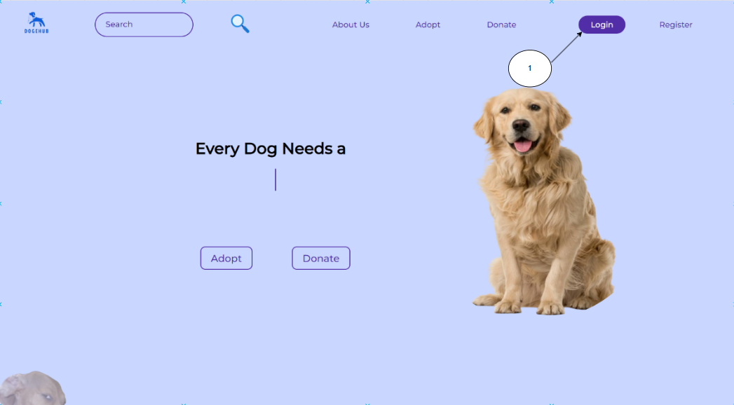

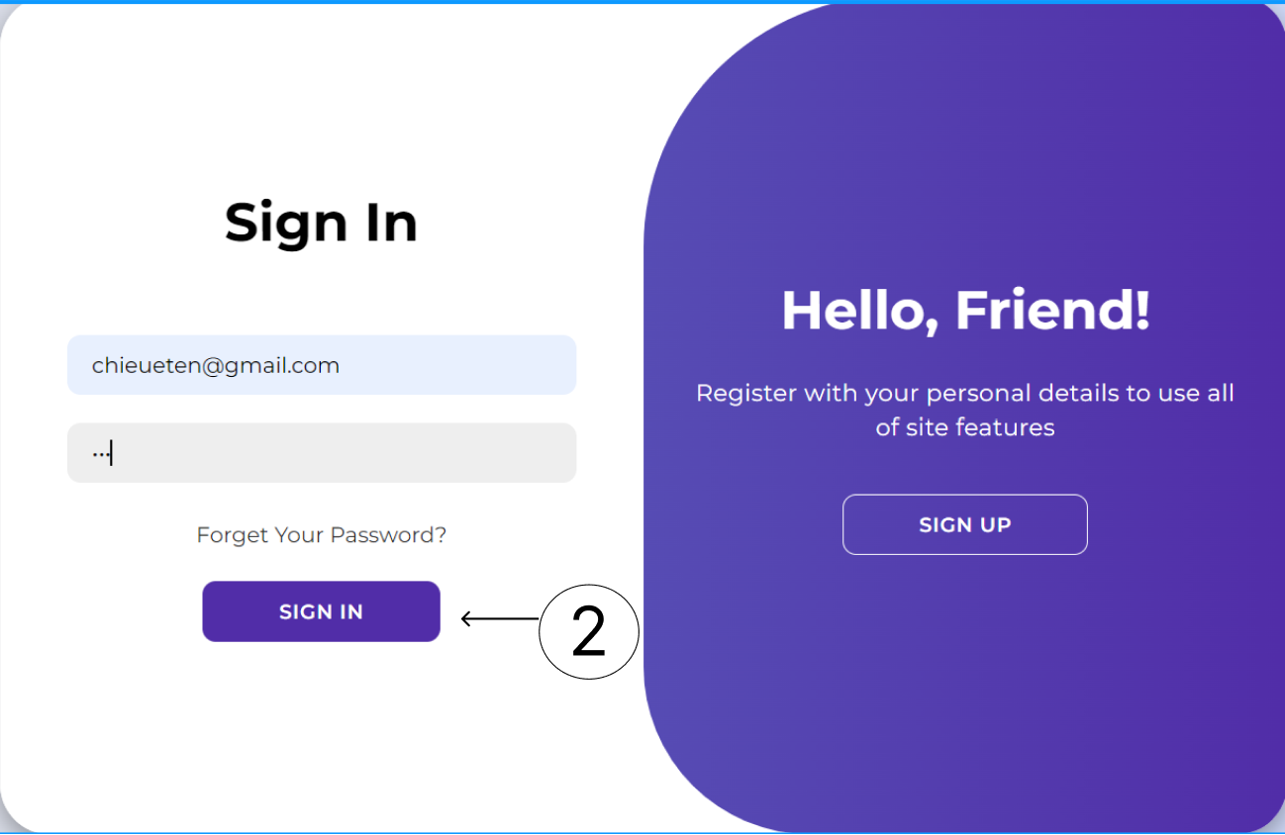

Users can login to the website with email and password if they have registered an account before.

## 4.2 User

### 4.2.1 Sign Up/Register

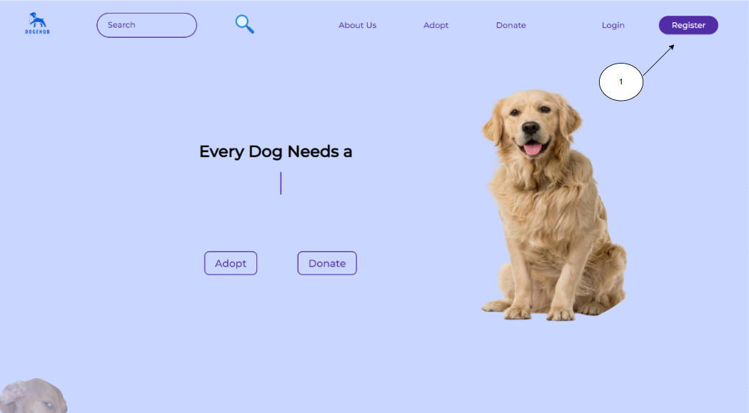

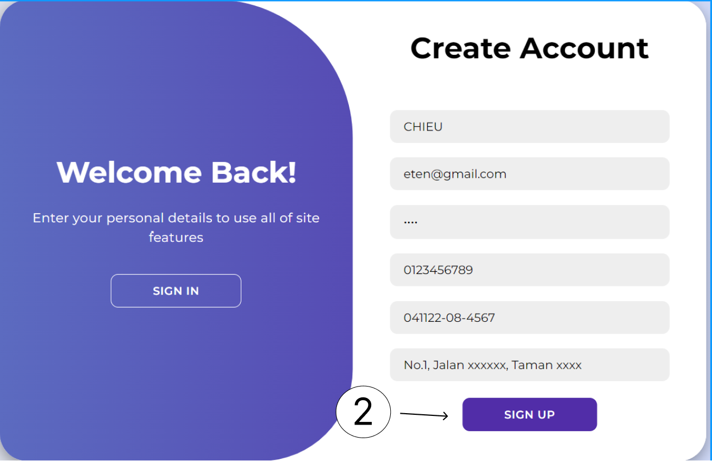

For those who wish to create an account, first click the register button. It leads to a page where people can create an account. Users can sign up once they have entered all of the required information.

### 4.2.2 Home Page

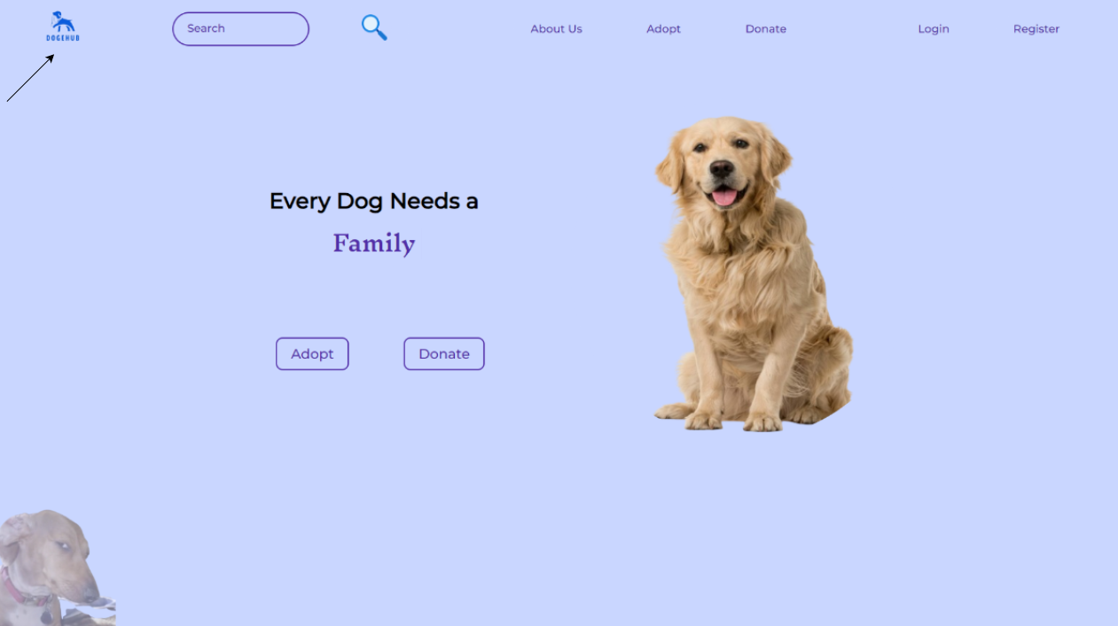

Figure 1 - User Home Page

To go back to Home page, user just need to click on the logo of Dogehub and it will redirect to the home page.

### 4.2.3 About Us

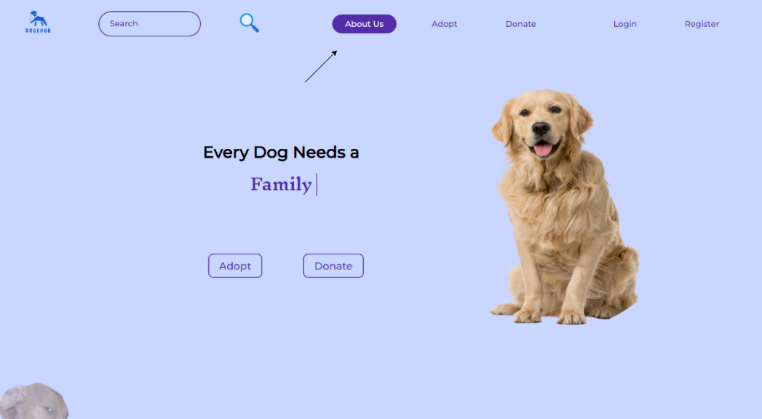

Figure 2 - Step to About Us Page

To access the About Us page, user just need to click on the “About Us” button on the header section and it will redirect to the page.

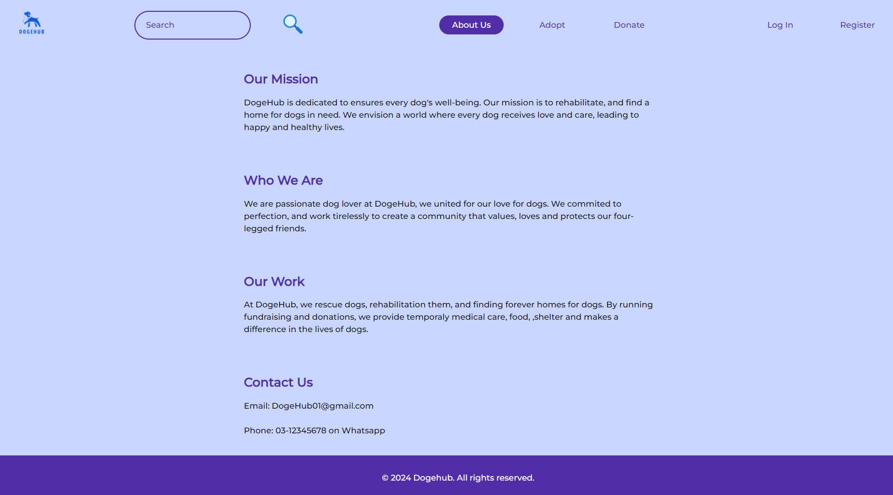

Figure 3 - About Us Page

The About Us page shows the Mission, Aim and the responsibilities of the organization.

### 4.2.4 Adopt Page

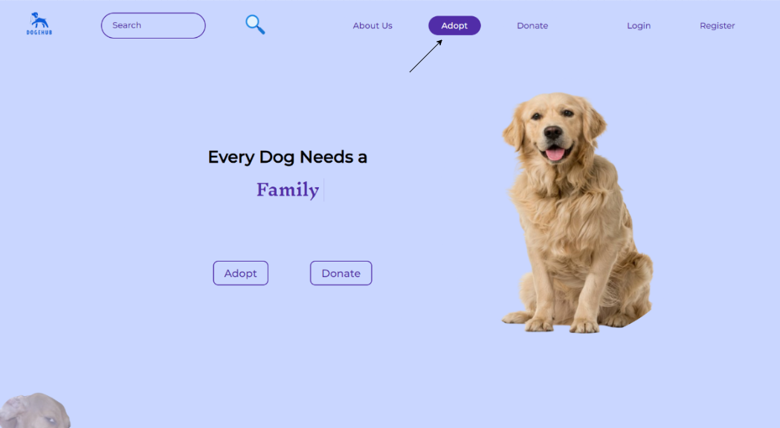

Figure 4 Step to Adopt page

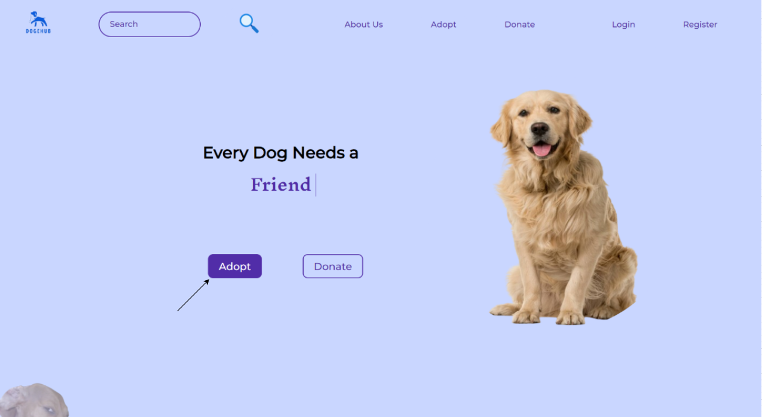

Figure 5 second way to Adoption page

There are 2 ways to access the Adopt page. Users can choose to click on the “Adopt” button on the header of the web page or click on the “Adopt” button on the middle of the Home page.

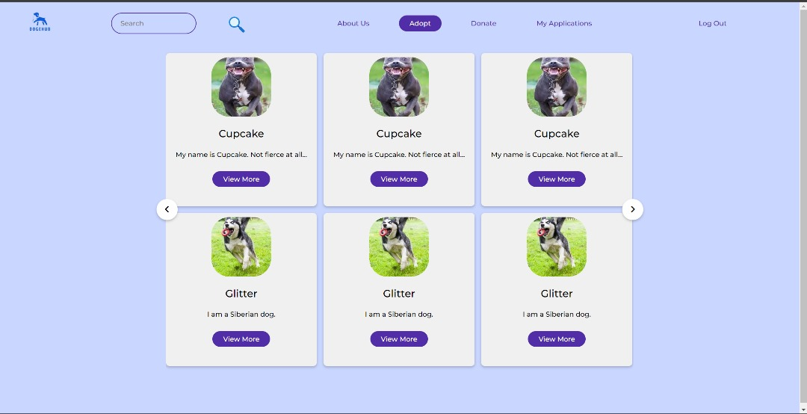

Figure 6 User Adopt page

After the user click the “Adopt” button, it will lead to this page and show what dogs are available.

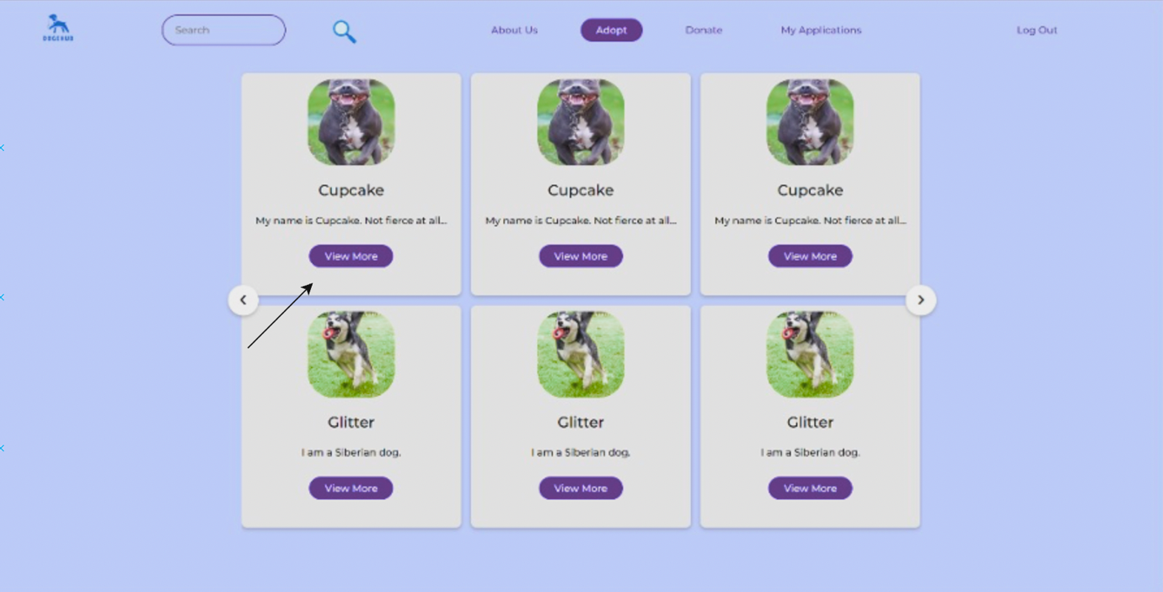

Figure 7 User to view more

If users are interested with the selected dogs, they can press the view more button to see more information about the dogs.

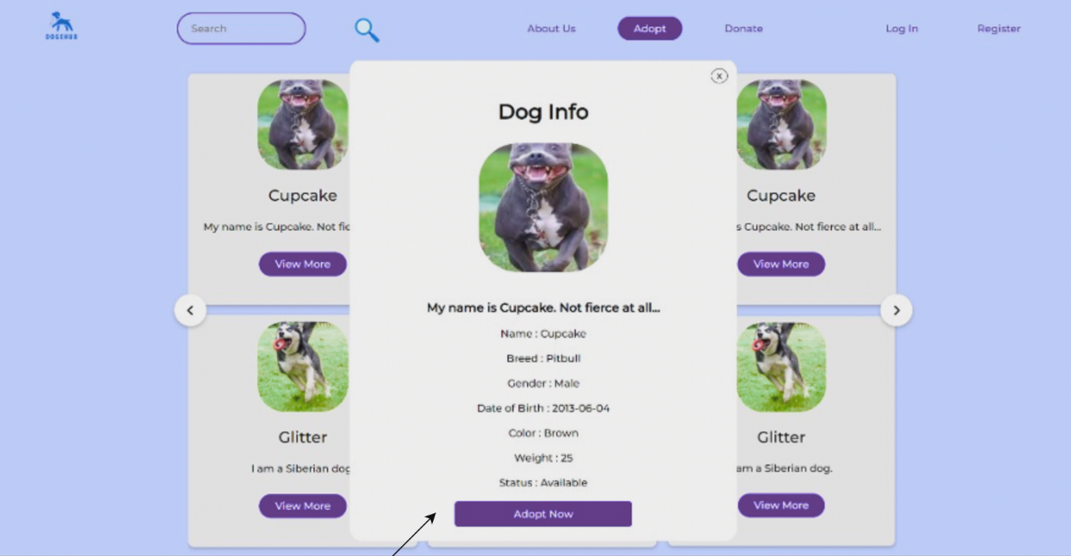

Figure 8 View more to see information

It will display the dog’s information and the button to Adopt now.

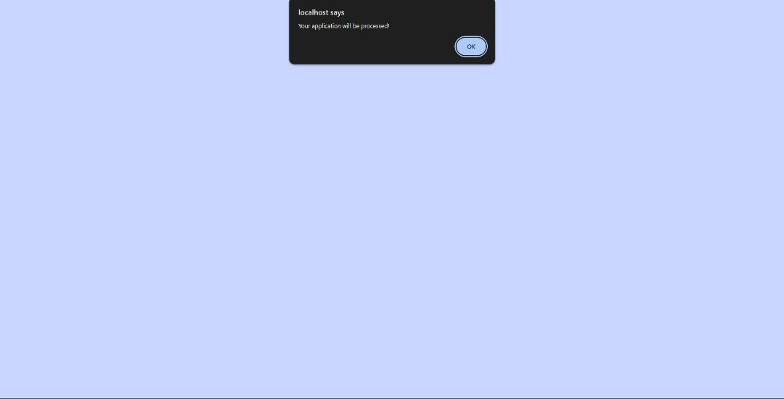

Figure 9 Adoption submitted

If users choose to adopt now, the website will show “your application will be processed”.

### 4.2.5 Application

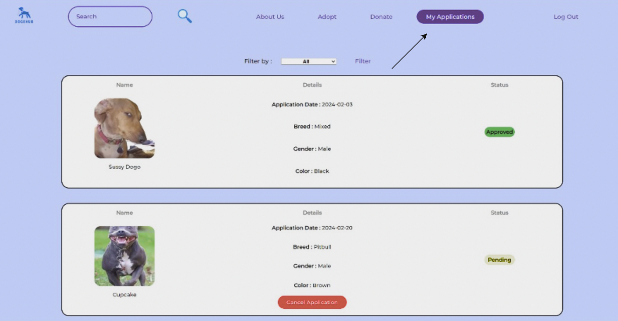

Figure 10 User to check application

Users can click on “My Applications” to check their submission status.

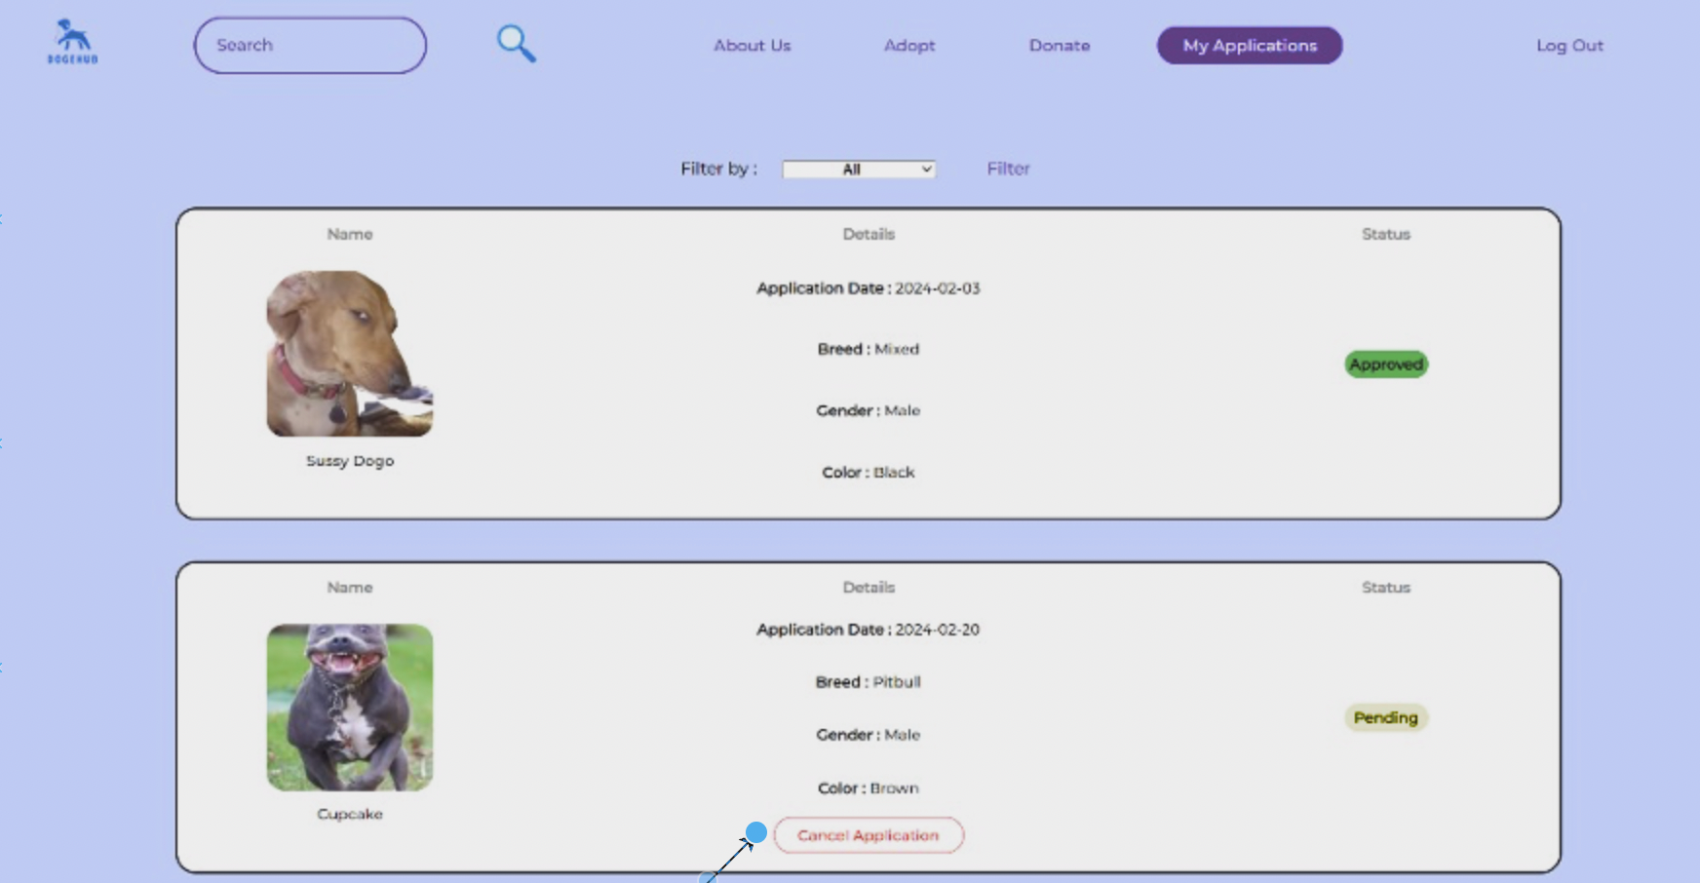

Figure 11 user cancel application

If users wish to cancel their applications, can click on the “Cancel Applications” button

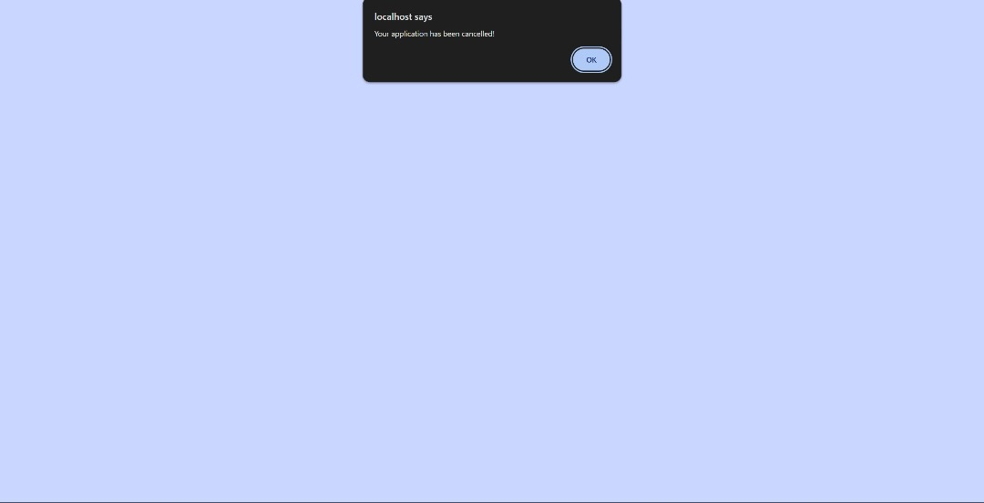

Figure 12 cancel successfully

If click cancel, it will show “Your application has been cancelled”.

### 4.2.6 Donate Page

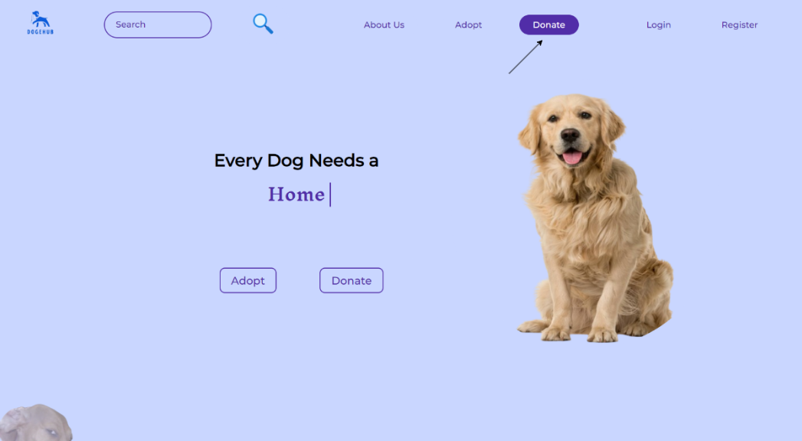

Figure 13 - Method 1 to Access Donate Page

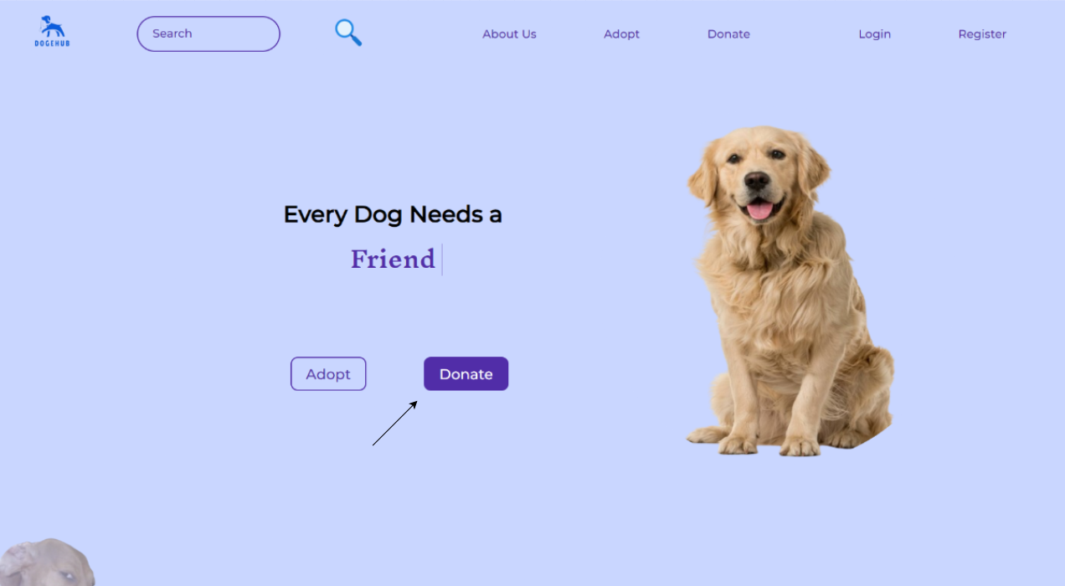

Figure 14 - Method 2 to Access to Donate Page

There are 2 methods to access the Donate page. Users can choose to click on the “Donate” button on the header of the web page or click on the “Donate” button on the middle of the Home page.

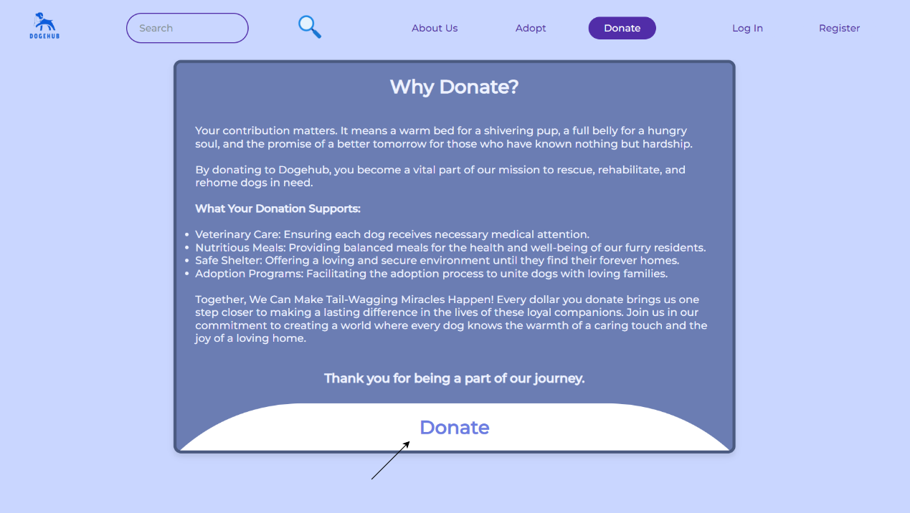

Figure 15 - Donate Page

The first view that comes to user eyes is the text of “Why Donate”. To proceed to donation process, user just need to click on the “Donate” button.

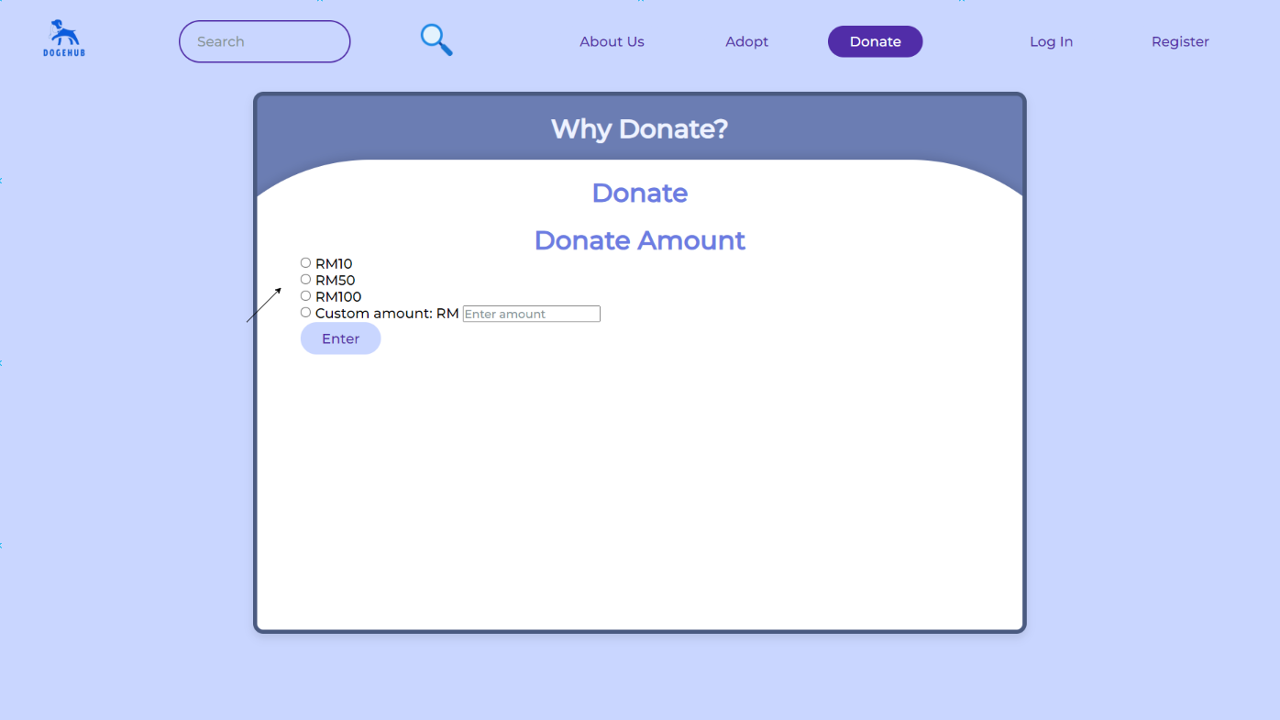

Figure 16 - Select Donation Amount

It will display the donation amount and customize the amount for user to select or enter.

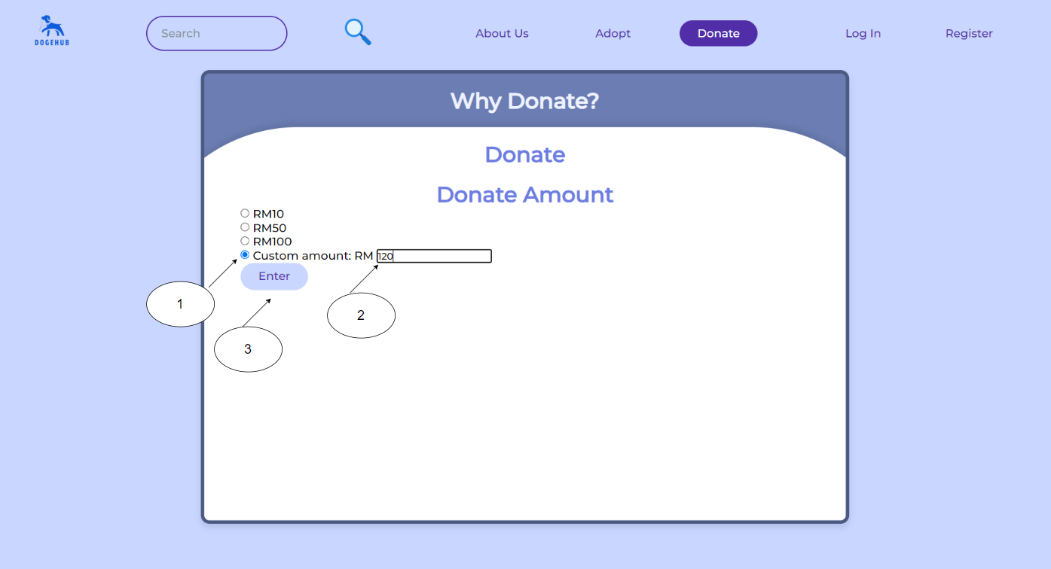

Figure 17 - Steps for Custom Amount

To customize the amount, the user just needs to follow the steps. Firstly, just click on the custom amount radio. Next, click on the textbox and enter prefer amount and lastly click on the “Enter” button. The required donation amount for custom amount is greater than RM10.

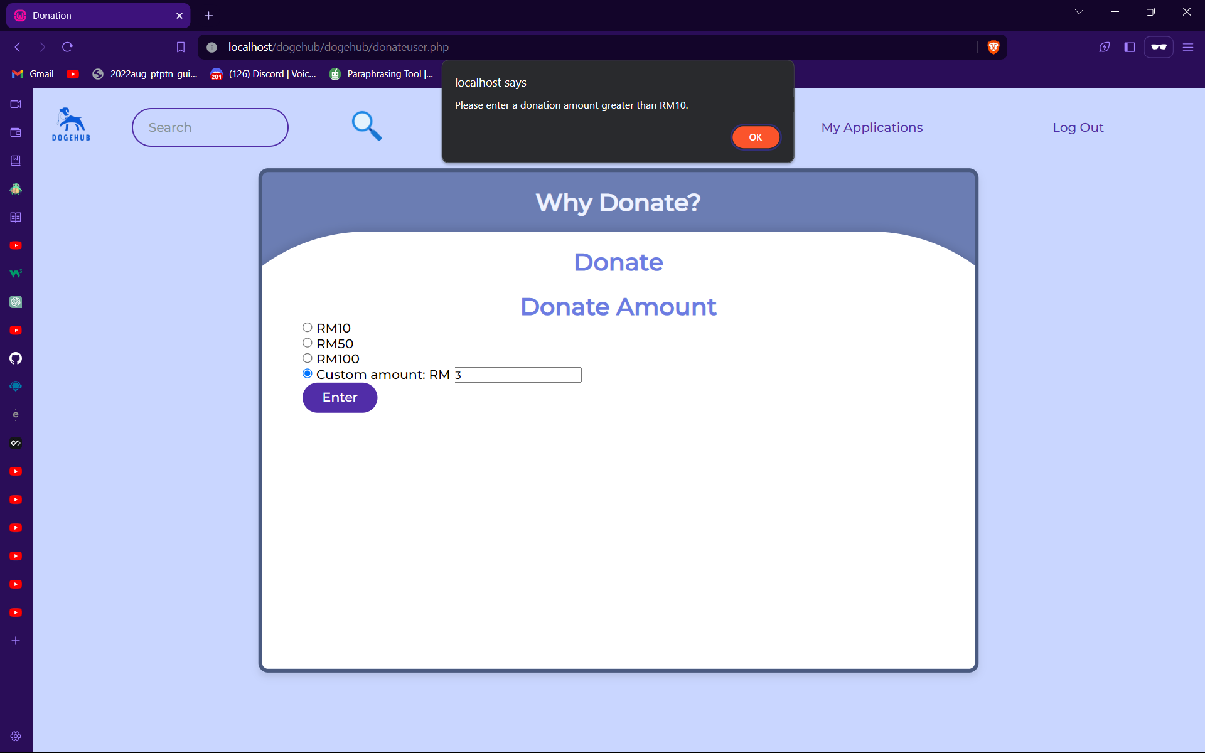

Figure 18 - Alert Message for Custom Amount

If user, enter amount lower than RM 10, the system will pop-up an alert message of “Please enter a donation amount greater than RM10.” Then, the system will clear the amount in the textbox and the user is able to enter a new value.

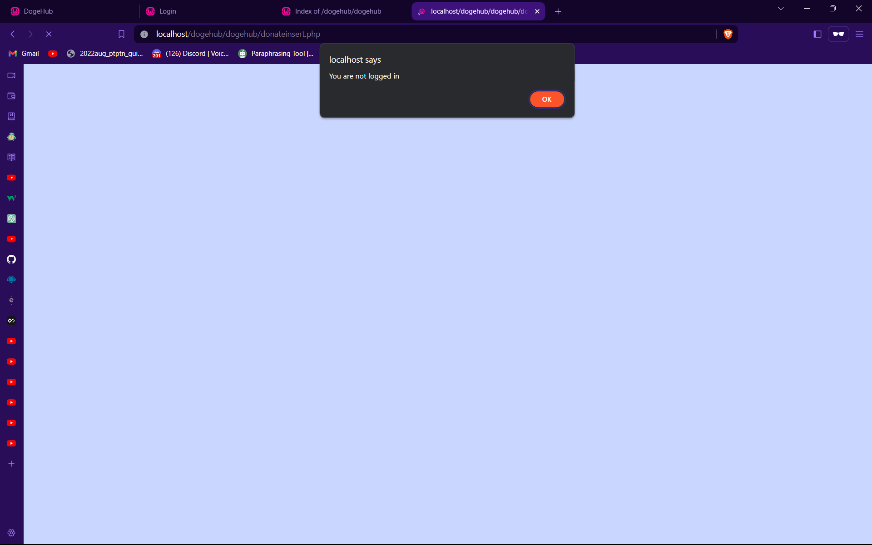

Figure 19 - No account Error Message

For user that did not login and selected an amount or customize amount, the system will pop out an alert message “You are not logged in.” Then, it will bring the user to the login page.

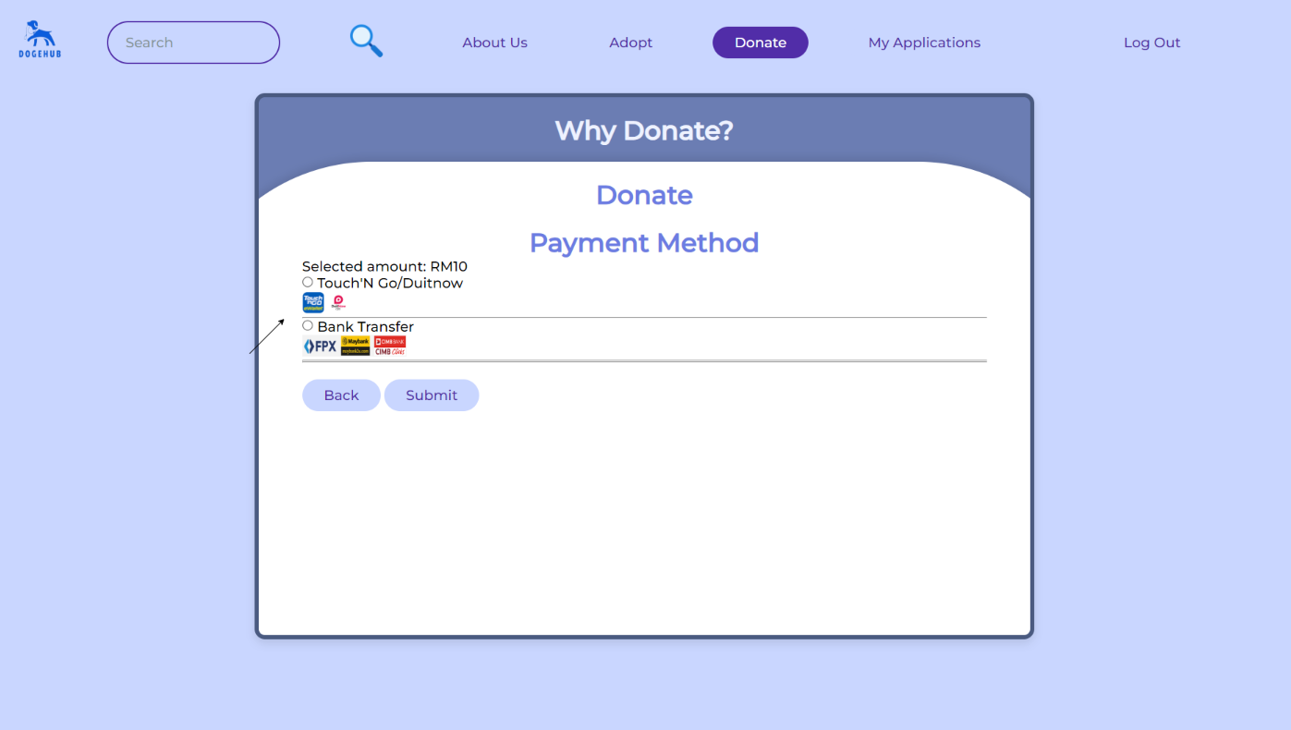

Figure 20 - Payment Method

After selecting an amount, the system will let the user to select a Payment Method. It will display the selected or customized amount first and following by payment methods which is “Touch’N Go/Duitnow” or “Bank Transfer”. Users just need to click on either one payment method to proceed.

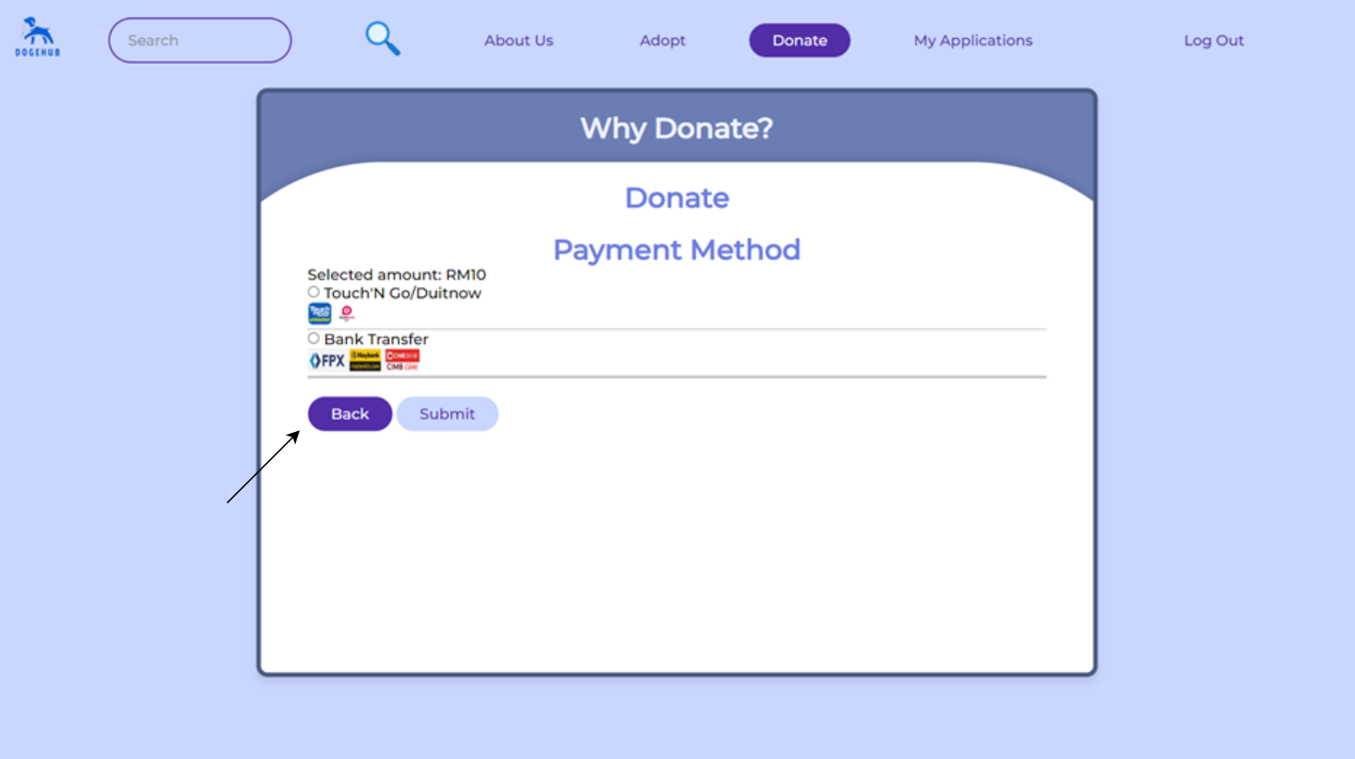

Figure 21 - Back to Select Donation Amount

For those users who want to reselect the donation amount, just click on the “Back” button.

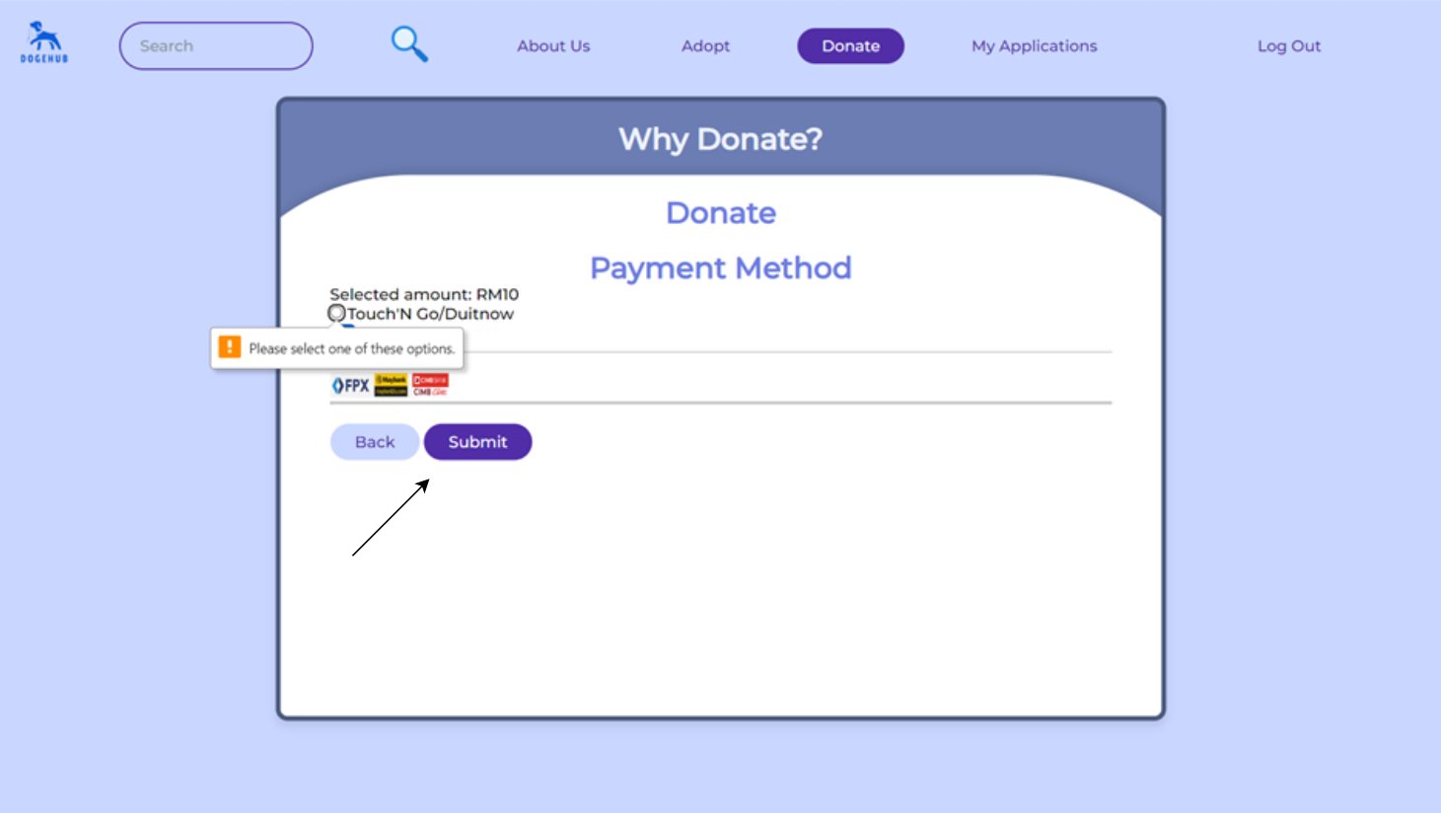

Figure 22 - No Selected Amount Error Message

If user click on the “Submit” button without selecting any payment method, it will display a message of “Please select one of these options.”

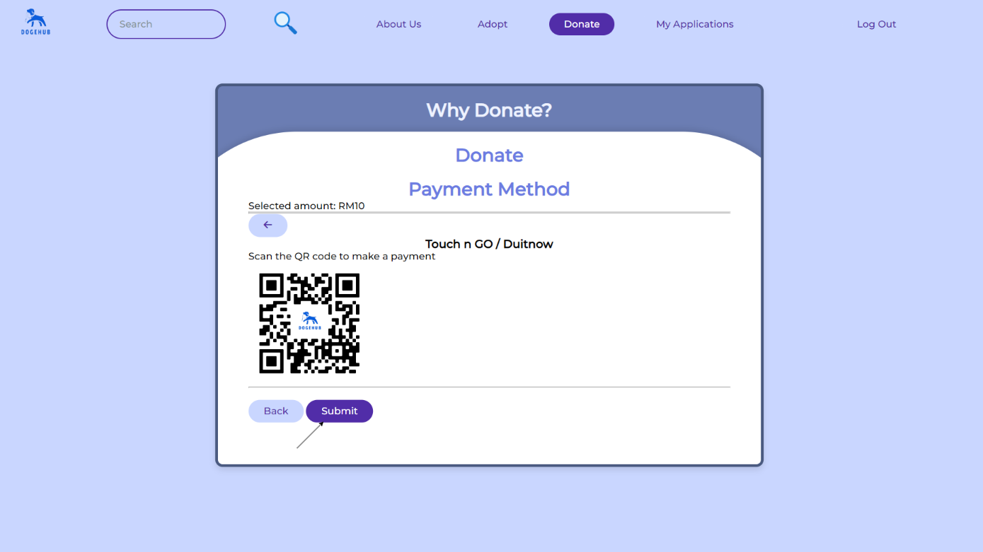

Figure 23 - Submit Payment for TouchNGo / Duitnow

For users who choose to use “Touch n Go / Duitnow” to pay, just scan the QR code and click on submit to let the system record the donation amount.

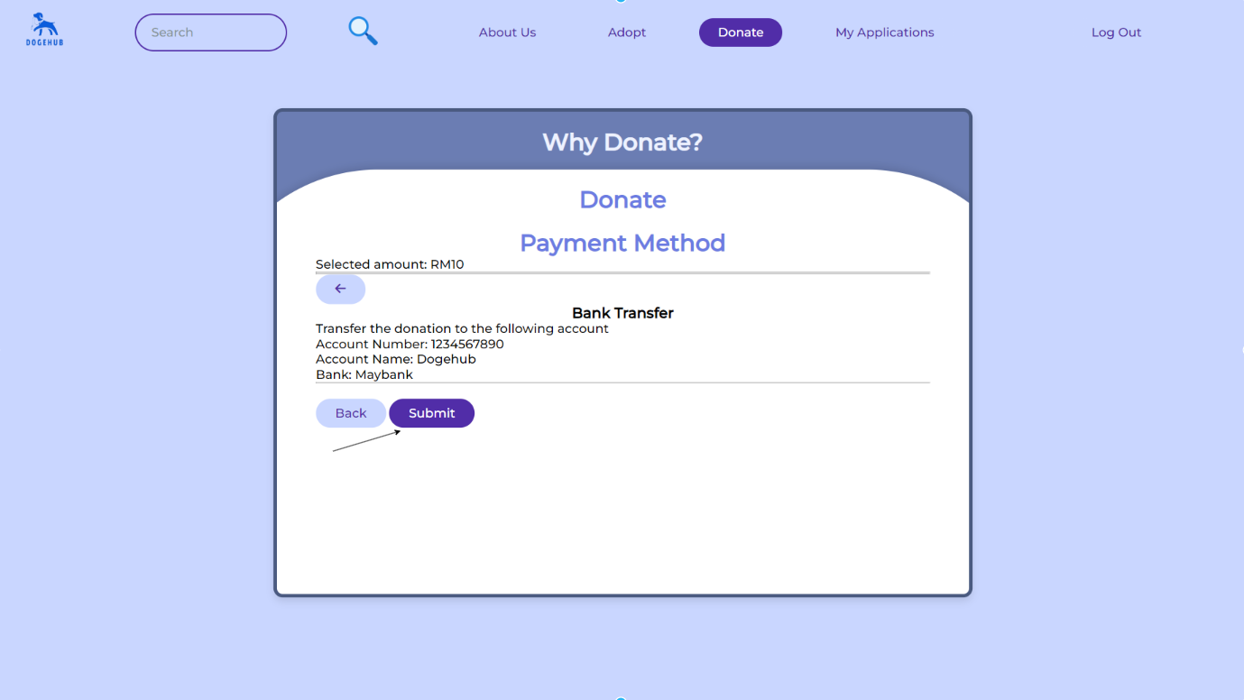

Figure 24 - Submit Payment for Bank Transfer

For users who choose to use “Bank Transfer” to pay, just enter the details of bank, account number and account name that provided and click on submit to let the system record the donation amount.

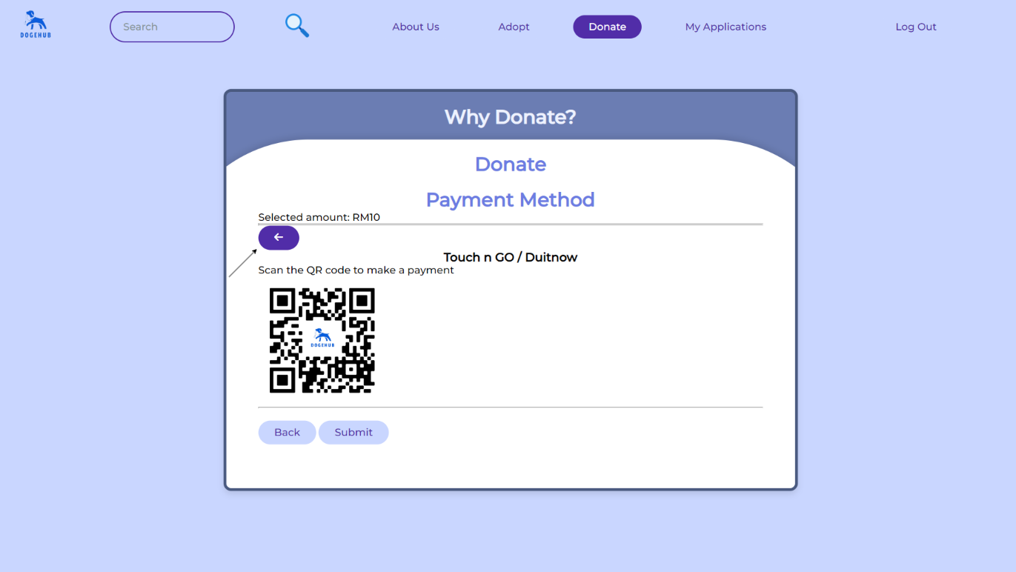

Figure 25 - Back to Select Payment Method from TouchNGo/Duitnow



Figure 26 - Back to Select Payment Method from Bank Transfer

To change the payment method, user just need to click on the left arrow (🡨) and it will go back to the Payment Method.

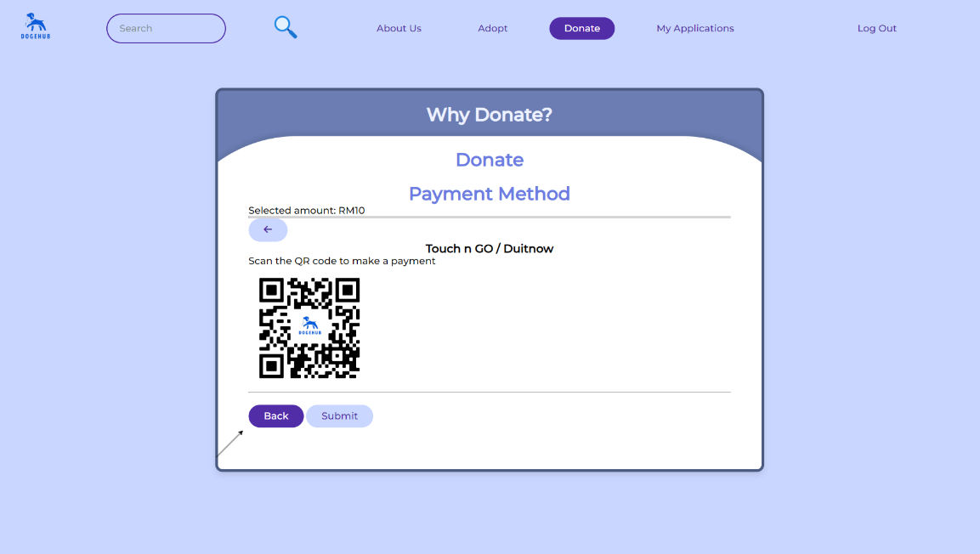

Figure 28 - Back to Reselect Donation Amount from TouchNGo/Duitnow

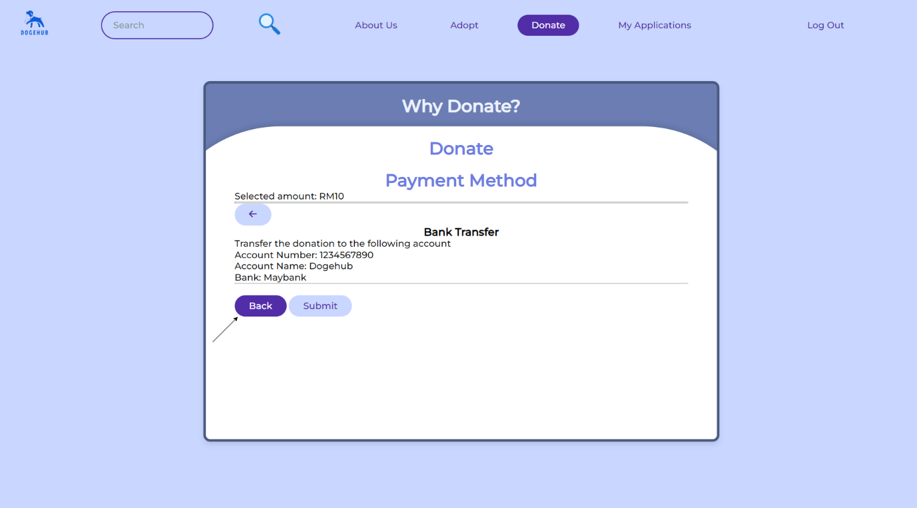

Figure 29 - Back to Reselect Donation Amount from Bank Transfer

To reselect the donation amount, user just need to click on the “Back” button.

### 4.2.7 Log Out

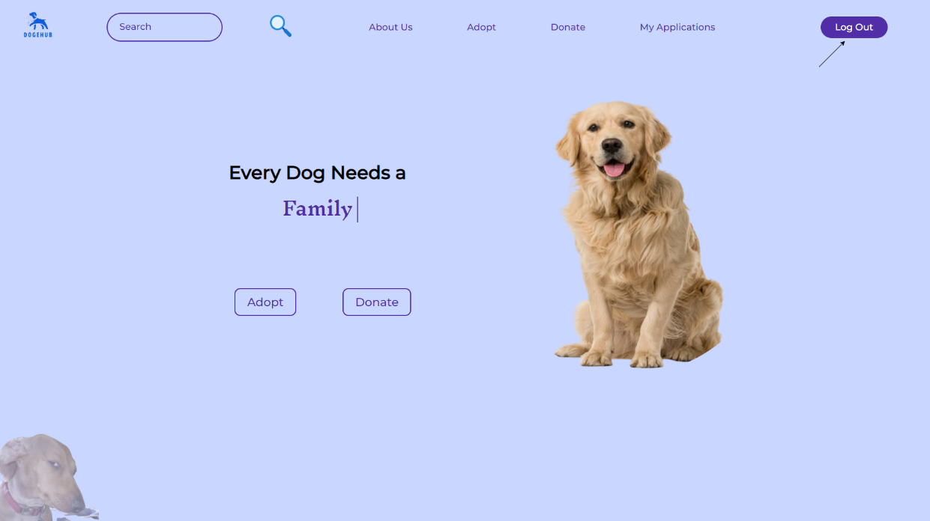

Figure 27 - User Log Out

If Admin wish to log out, just click on the “Log Out” button.

## 4.3 Admin

### 4.3.1 Home Page

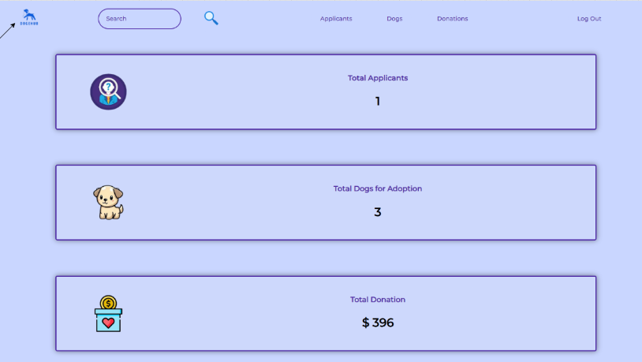

Figure 30 - Admin Home Page

Admin can view Total Applicant, Total Dogs for Adoption and Total Donation. To go back to Home page, admin just need to click on the logo of Dogehub and it will redirect to the home page.

### 4.3.2 Edit Adoption

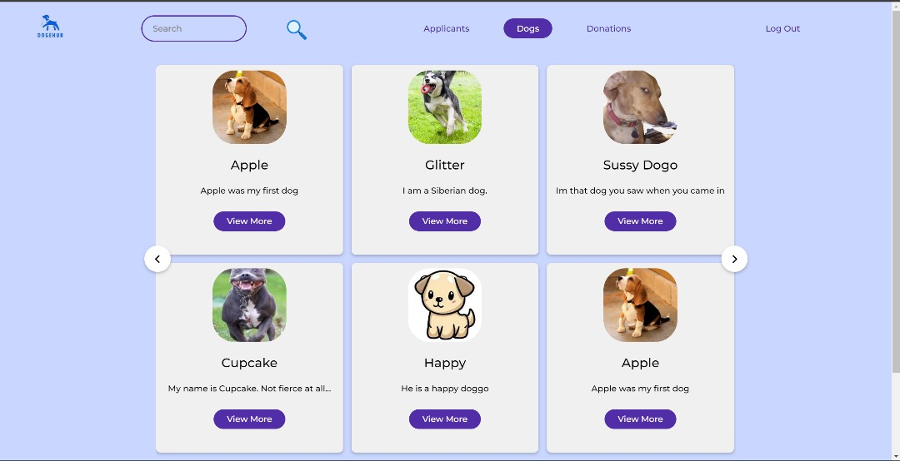

Figure 31 Admin adopt page

This is the admin dog adoption page.

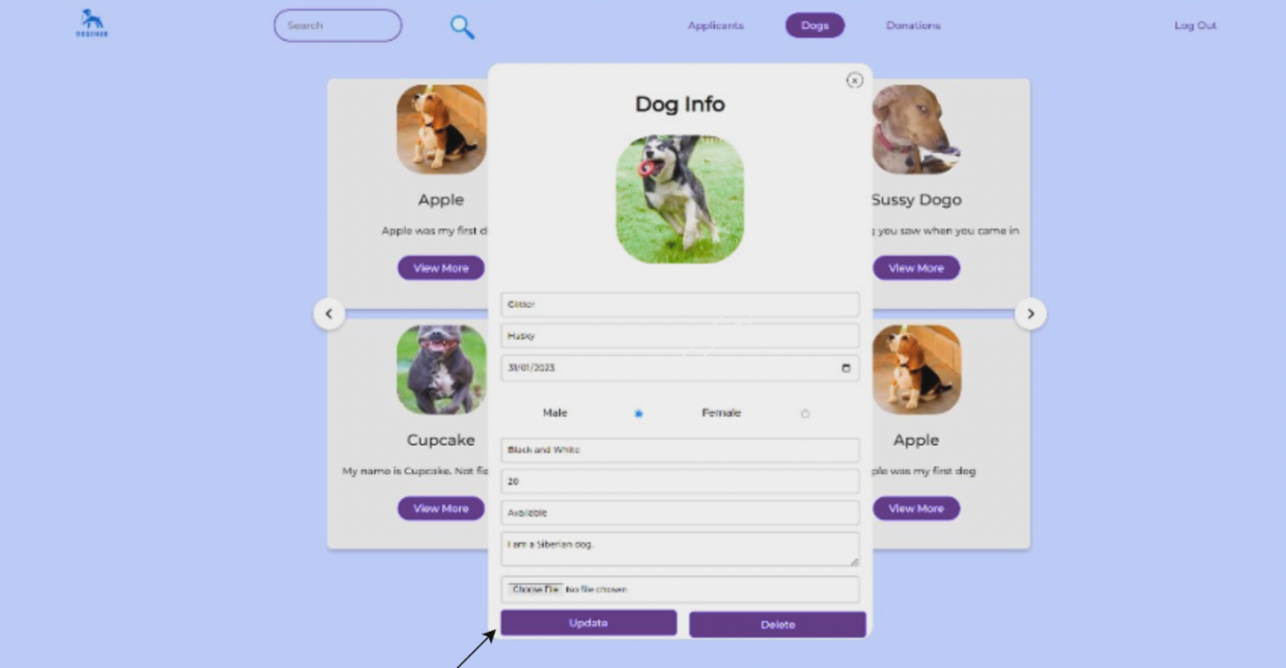

Figure 32 Admin view more to update or delete

Admin can view to update or delete.

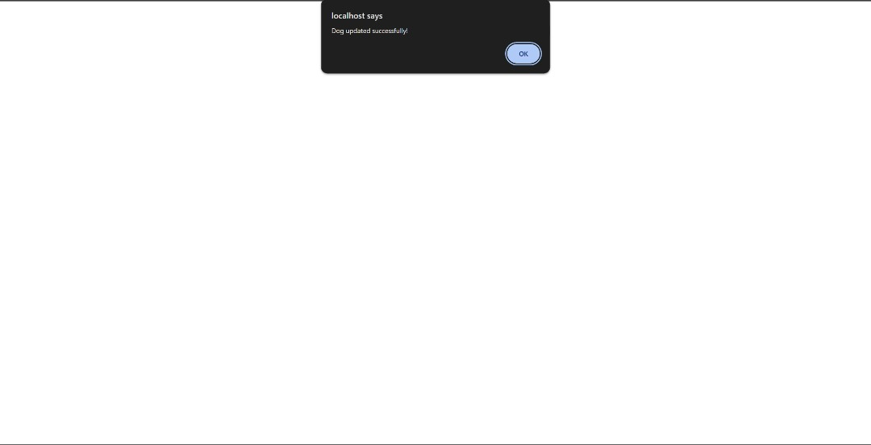

Figure 33 Successfully Updated

If click update, it will show “Dog updated successfully”.

### 4.3.3 View User’s Application

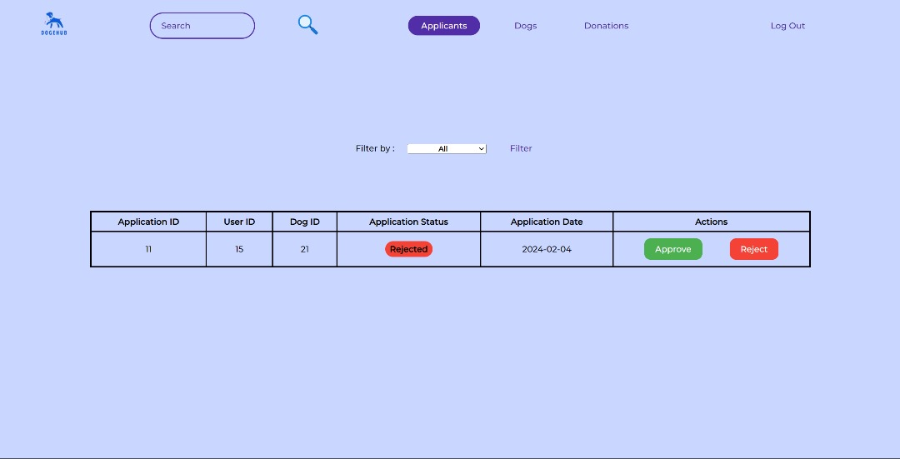

Figure 34 Admin approve or reject applicants

The table shows Application ID, User ID, Dog ID, Application Status, Application Date, Actions

After users have submitted their applications, the admin will receive their applicants to approval or reject

it only shows status = "pending" by default and rejected

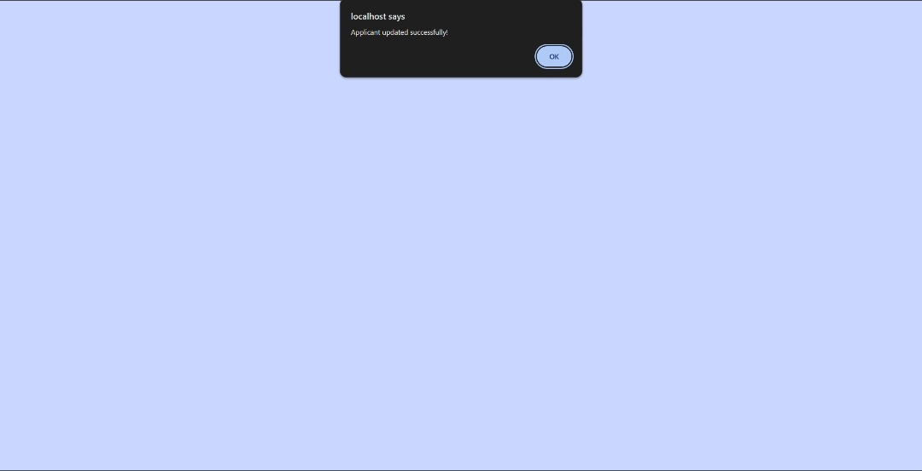

Figure 35 Adoption result

Once admin approves or rejects, the website will show “Applicant updated successfully !”

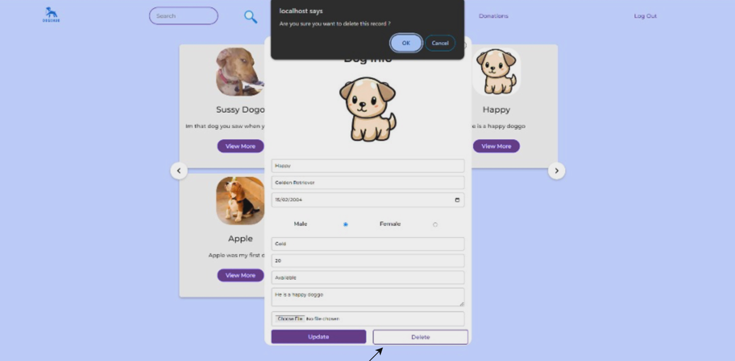

Figure 36 Admin to delete

If the admin wish to delete the dog record, the JavaScript alert will show up

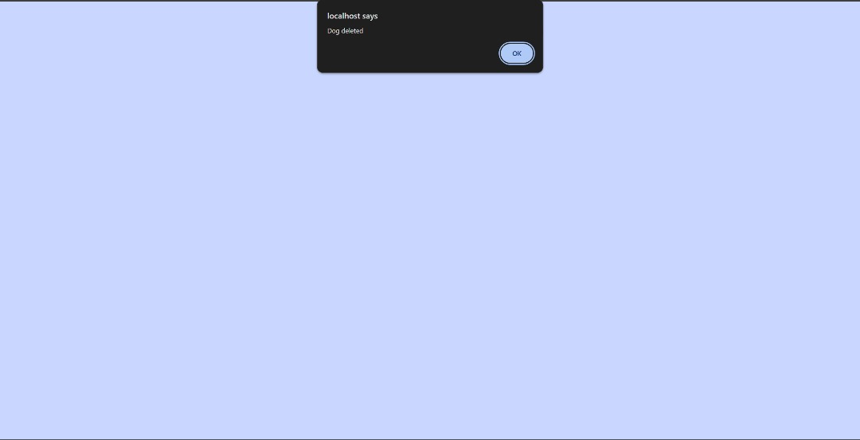

Figure 37 Delete successfully

If ok, the website will notice “Dog Deleted”.

### 4.3.4 View Total Donation

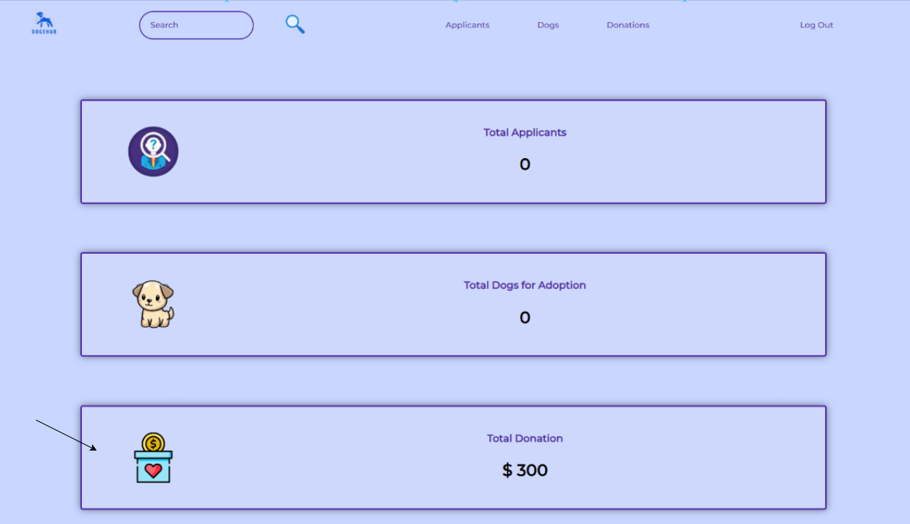

Figure 38 - Steps to View Total Donation

To view the Total Donation, admin needs to click on the “Total Donation” button which also shows the total amount of donation to access to Total Donation page.

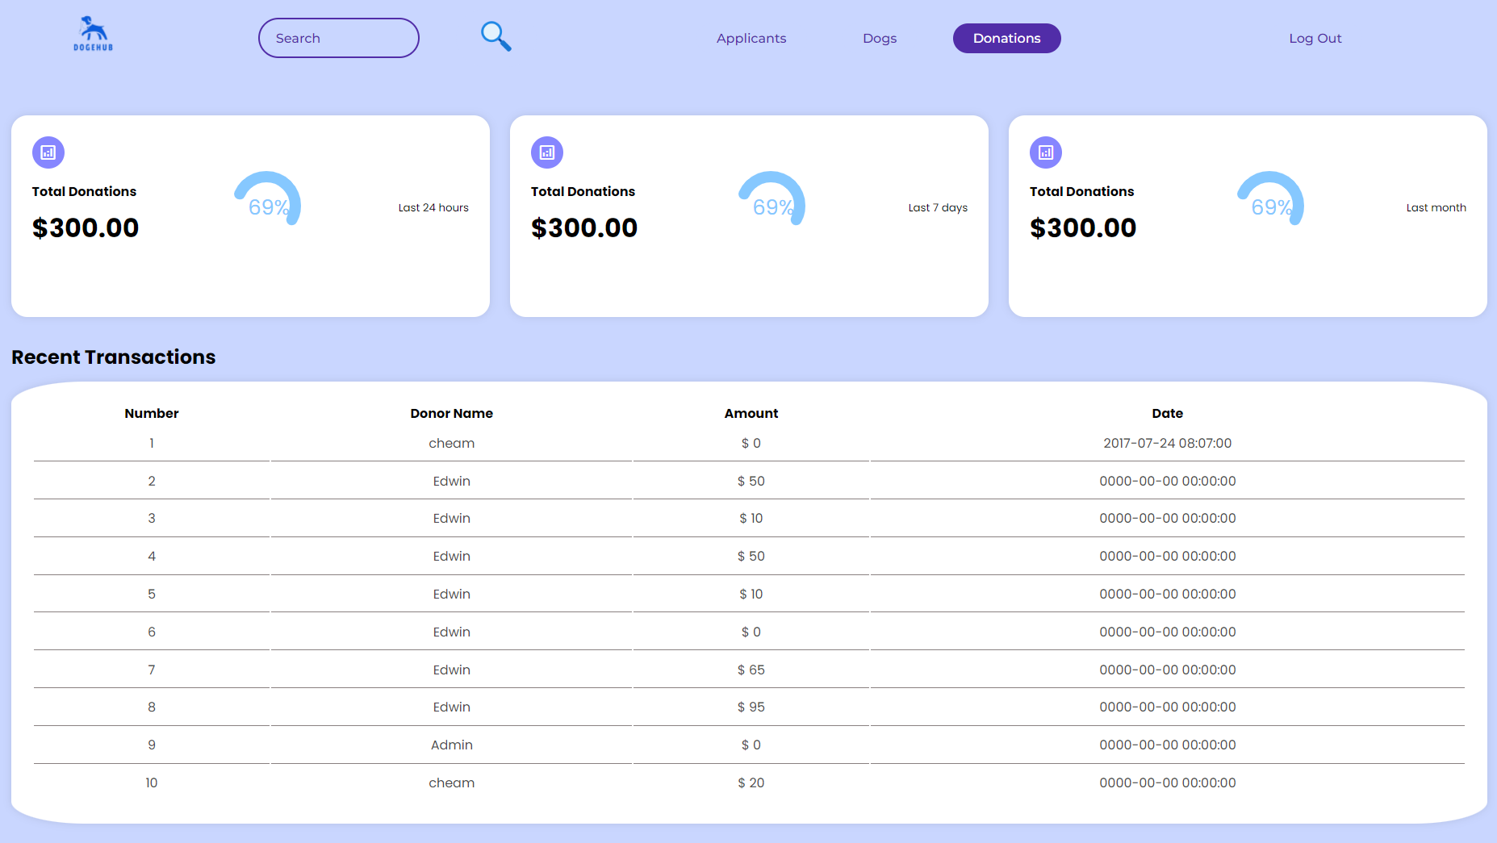

Figure 39 - Total Donation Page

The total donation page displays the total donation collected within a specific time range from 24 hours to month. It also displays the last 10 recent transactions.

### 4.3.5 Log Out

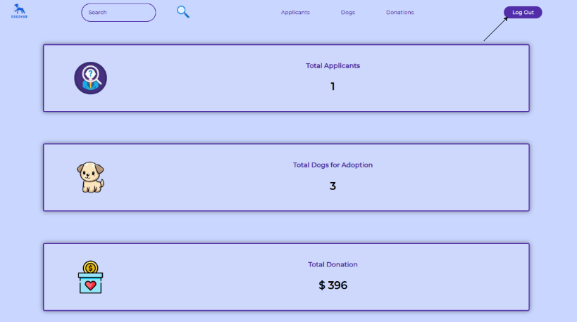

Figure 40 - Admin Log Out

If Admin wish to log out, just click on the “Log Out” button.

# **CONCLUSION**

In conclusion, DogeHub is all about creating a better environment for our furry friends. Through the DogeHub platform, we were able to develop a place where admin can easily manage dog information, user’s donation, and adoptions, while user can easily view details of dogs, explore their opportunities of seeking their dream dogs and keep supporting the platform by donating.

Though, the platform is good enough for the present situation, it might change in the future due to changes of the environment and the society. There are still improvement and enhancement we can do, let’s have a short discussion of this topic.

The first enhancement to the platform will be implementing user-generated content. For example, registered user can post their stories, pictures or even video of their dogs on the platform. It can expand the community to more people and helping people on understanding the procedure by sharing their own experiences on adopting a dog. It is good for dogs that are still waiting for a person to give them a warm house as more people will notice them, it is also good for the platform as we can get more donation to help more dogs that are in need.

Moreover, expanding collaboration with more shelters, organization, or even veterinary clinics when our platform is huge enough to helps. As stated in our goals, we wanted to help as many dogs as possible, so there is absolutely no reason to not help others fellow enthusiast that share the same thought and goal with us. By having more partnership will be a huge boost on helping more dogs that were still outside there in the streets.

Lastly, adding a machine learning algorithms or an AI can also be a big improvement, since the current search function in the platform is just using matched result. Having an algorithm can improve the accuracy of matching between dogs and potential adopter, it results in more successful adoptions case which is good for all the parties.

# **REFERENCES**

w3school. (2022). JavaScript Popup Boxes. *w3school*, 1-10.

# **WORKLOAD MATRIX**

|  |  |
| --- | --- |
| Cheam Sheng Ting TP071172 | (Report)  Entity Relationship Diagram, Data Dictionary  (Website)  Home (User & Admin), Admin applicants, admin dog page |
| Edwin Chen Choon Mun TP071367 | (Report)  Implementation (Donate Page), User Guidance (Home Page, About Us, Donate Page, Log Out)  (Website)  Donate Page (User) |
| Chai Ming Xuan TP071180 | (Report)  Introduction, Design (Website Navigational Structure, Wireframe), User Guidance, Conclusion  (Website)  About Us Page |
| Chieu Eten TP071064 | (Report)  Implementation (Login and Sign in Page, Admin view donation page)  User Guidance (Login and Sign in Page, Admin view donation page)  (Website)  Login, Sign in, Admin view donation page |
| Lee Kai Yang TP071258 | (Report)  Implementation (Adopt page (user & admin )), User Guidance (Adopt page (user & admin))  (Website)  Adopt page (admin / user ) |